**Amazon Sales forecasting model**

*Pooja Shah*

**Table of Contents**

1. **Executive Summary**
2. **Data Overview**
   1. Explaining Amazon data set
   2. Column summary
   3. Data cleansing
3. **Data Exploration**
   1. Exploring dependent variable
   2. Exploring independent variables
      1. Checking for time series
      2. Checking for cross-correlations

3.3 Checking for stationarity

**4. Modeling and forecasting**

4.1 Finalizing key independent variables

4.2 Determining right set of models

4.3 Modeling and forecasting

4.3.1 ARIMA

4.3.2 ARIMAX

**5. Model comparison**

5.1 Accuracy & fit statistics with and without hold out sample

5.2 Final Forecasting Parameters & Equation

**6. Conclusion**

**1. Executive Summary:**

The dataset contains historical sales data for 45 Amazon stores located in different geographies. Every store contains 98 departments and each of the departments has got a certain weekly sale. The data contains 3 years of data for the time horizon: 2019-02-05 to 2021-11-01 split at weekly level for 45 Amazon stores. We will be evaluating time-series forecasting to determine sales for one of these stores.

By understanding the sales trends, the store can work on optimizing inventories for lean periods and jack up the inventories where the sales would shoot up. Also, stores can run promotional events to gain an uplift in sales in case the projections show feeble sales in the coming weeks.

We have run model of ARIMA and ARIMAX with mean weekly sales as dependent variable, and temperature, fuel price, CPI, unemployment, and holiday as independent variables. We have run ARIMA(0,2), ARIMAX(2,0), ARIMAX(1,0), ARIMAX(2,2), ARIMAX(0,2), ARIMAX(0,0), ARIMAX(1,1), ARIMAX(0,1).

We found out that ARIMAX(2,0) is best model because looking at the accuracy and statistics fit, ARIMAX(2,0) has the lowest MAPE - 2.2% than any other models. In addition, it has no significant autocorrelation exists and has slightly white noise, whereas other models appear to either have autocorrelation or white noise.

In summary, ARIMAX(2,0) is optimal models for business and shows the declining of the sales trend the forward time horizon. Given that the macroeconomic indicators shows a positive trend, the forecast shows a decline in sales, hence, the recommendation for the business would be investigating the factors leading to drop; department level sales trends can be understood to find critical focus areas; and other indicators like quality, delivery of service, price points can be evaluated to understand if there are other factors influencing the sales.

**2. Data Overview:**

**2.1 Explaining Amazon dataset:**

The dataset contains historical sales data for 45 Amazon stores located in different geographies. Every store contains 98 departments and each of the departments and each of the departments has got a certain weekly sale. The data has 3 years of data for the time horizon: 2019-02-05 to 2021-11-01 slip weekly level of 45 Amazon stores.

By understanding the sales trends, the store can work on optimizing inventories for lean periods and jack up the inventories where the sales would shoot up. Also, stores can run promotional events to gain an uplift in sales in case the projections show feeble sales in the coming weeks.

**Amazon sales dataset source:**

https://data.world/revanthkrishnaa/amazon-uk-sales-forecasting-2018-2021/workspace/project-summary?agentid=revanthkrishnaa&datasetid=amazon-uk-sales-forecasting-2018-2021

**2.2 Column summary:**

|  |  |
| --- | --- |
| **Column Name** | **Column Description** |
| Store | The store number |
| Dept | The department number |
| Date | The week |
| Weekly_Sales | Sales for the given department in the given store |
| Temperature | Average temperature in the region |
| Fuel_Price | Cost of fuel in the region |
| CPI | The consumer price index |
| Unemployment | The unemployment rate |
| IsHoliday | Whether the week is a special holiday week |
| Mean | The average of weekly sales in each store |

**2.3 Data cleansing:**

We cleaned the data in the Excel sheet, changed the format of the “Date” from dd/mm/yyyy to mm/dd/yyyy, and deleted four columns – “Type”, “Size”, “Total_MarkDown”, and duplicated column “Date” as they were not necessarily needed for the forecasting. The data has 45 Amazon stores, therefore, we used only “1” segment in the “Store” column.

**Accumulation function**: Also, we have taken aggregation of this weekly data which is for week’s mean sales and not total actual sales. This is to ensure that the impact of price changes, promotions, etc. is not factored in and the data is smooth.

**3. Data Exploration:**

After data cleansing, mean weekly aggregated  sales of Amazon store 1 is chosen as the dependent variable. Next, we had 5 independent variables: Temperature, Fuel_Price, CPI, Unemployment, and IsHoliday. All of these variables will be further explored below.

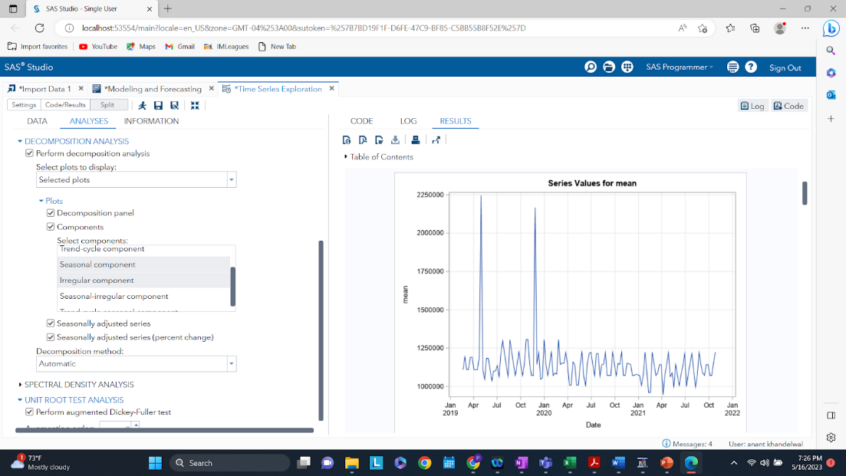**3.1 Exploring dependent variable:**

*Fig. 1 - Mean Sales Time Series*

From just the time series plot above, generally a trend and seasonality component is seen for aggregated weekly mean sales for Amazon Store 1. But further decomposition is required to extract the signals into the different components. Lastly, the time series consists of data points for 3 years broken up into aggregated weekly mean sales.

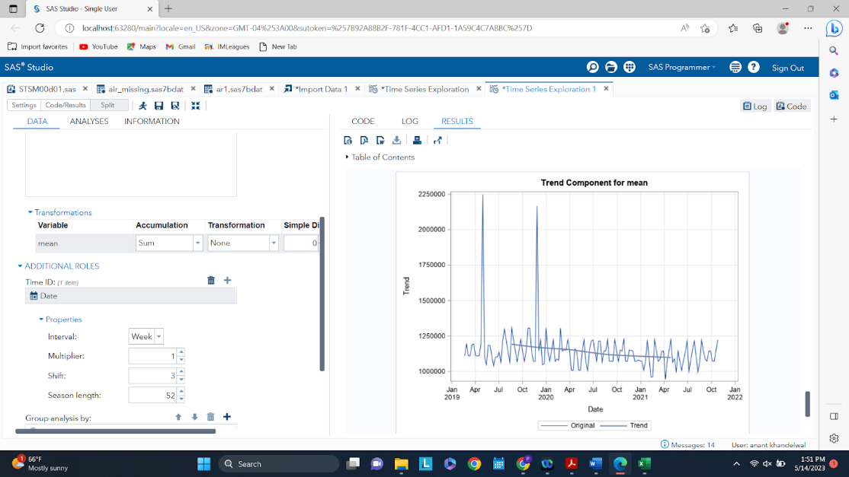

*Fig. 2 - Trend Component of Mean Sales*

Clearly, a trend is seen in the decomposed trend component of the time series. A declining trend is seen, meaning that from Jan 2019 - Jan 2022, the aggregated weekly mean sales for Amazon store 1 are declining. This is something that will have to be investigated further.

Fig. 3 - Seasonality Component of Mean Sales

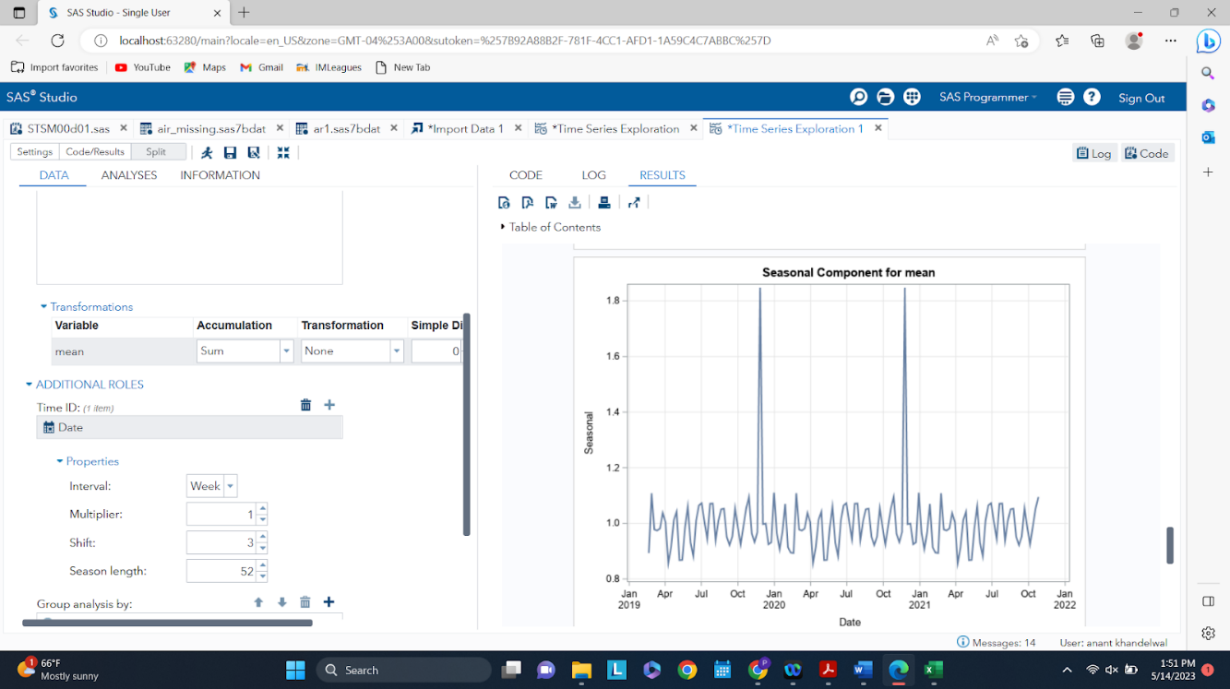

Next, above we see the decomposed time series, showing the seasonal component. A relatively clear seasonality is shown in the plot above, with a high point seen between November and December for both the year of 2020 and 2021. A low point is generally seen in April of each year and the overall pattern repeats itself. Therefore, the time series data does consist of a seasonal component.

Fig. 4 - Seasonal Cycle Plot

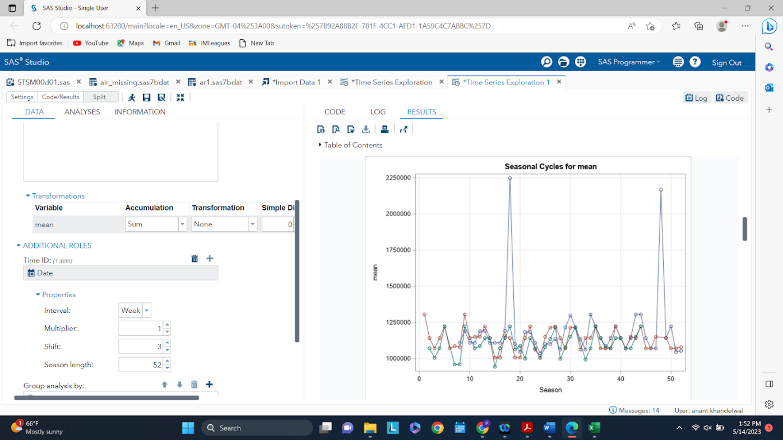

To further solidify the fact that a seasonal component and pattern exists, the seasonal cycle plot is examined. As seen from this plot above, similar to the seasonal component of mean plot, a general pattern or seasonality is seen. Therefore, the time series does indeed have a seasonal component.

Fig. 5 - Irregular Component of Mean Sales

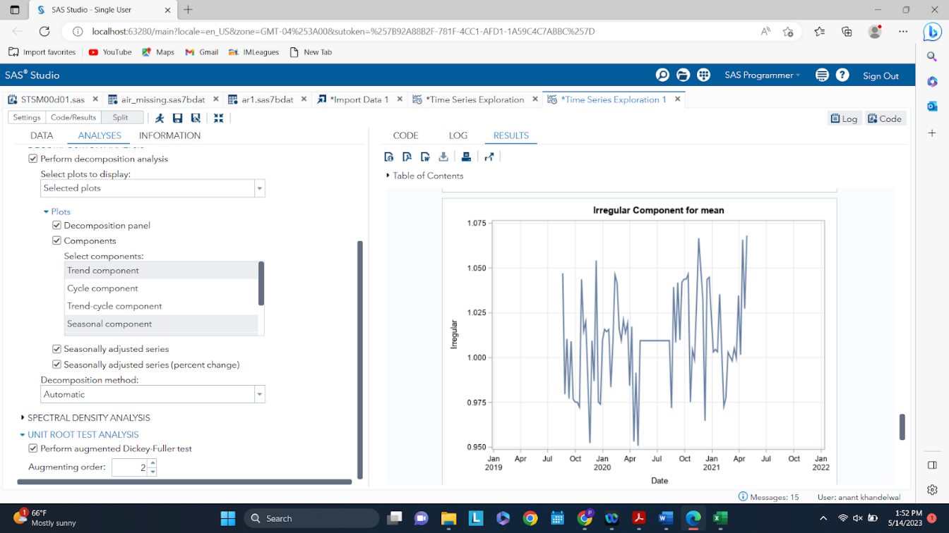

Finally, examining the irregular component after decomposing the dependent variable. No trend or seasonality can really be seen or extracted from this.

Fig. 6 - Correlations for Mean

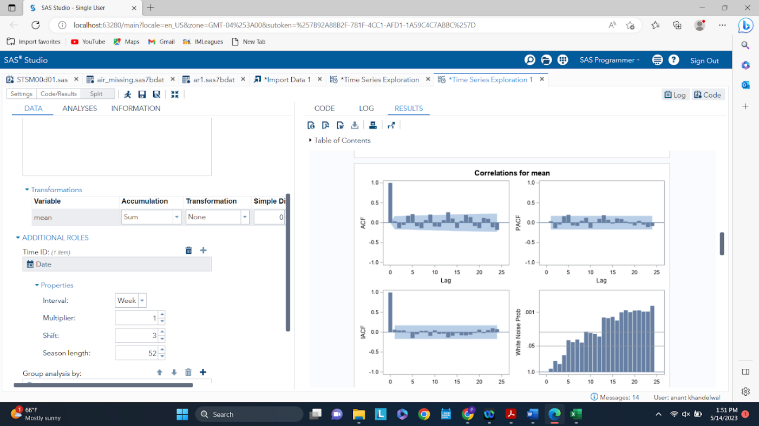

Further examining the ACF, PACF, IACF, and the White Noise Test, a signal is present in the dependent variable of the dataset. Therefore, it is fair to assume that trend and seasonal components have to be extracted to help describe the given time series. However, further modeling and analysis will be required to completely extract the signal, by looking at tests and metrics, such as the white noise test.

**3.2 Exploring independent variables**

Having looked at the dependent variable aggregated weekly mean sales of the Amazon store, the attention will now shift to exploring 5 of the given independent variables that may have an impact on the target variable. The independent variables will first be explored further to see if they are also time series, in which case pre-whitening will have to be done. Lastly, cross-correlations will have to be run between the dependent variable and the independent variables before moving on to modeling.\

**3.2.1 Checking for time series**

Fig. 7 - Temperature Time Series

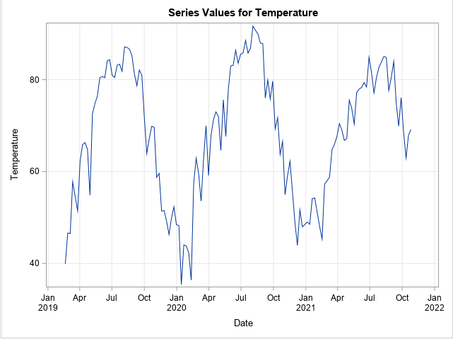

From the plot above, it can be seen that a general seasonal pattern is seen. But the trend seems quite flat. Hence, it can be concluded that temperature is a time series, as expected. As months change in a year, the temperature generally experiences a seasonal shift as well. Below are the decompositions of the time series for temperature to further examine the components.

Fig. 8 - Trend Component of Temperature

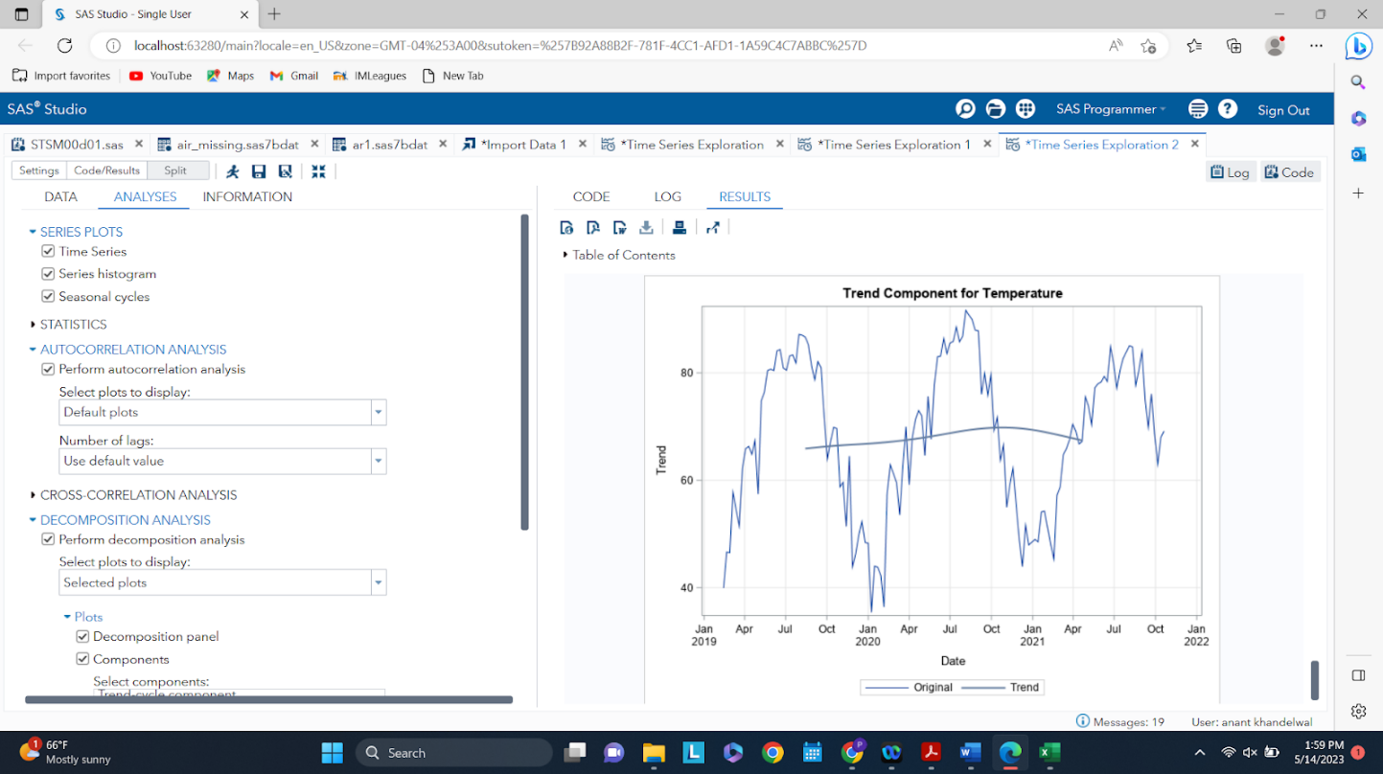

As mentioned earlier, the trend seems quite flat, so the temperature time series does not consist of a trend component.

Fig. 9 - Seasonality Component of Temperature

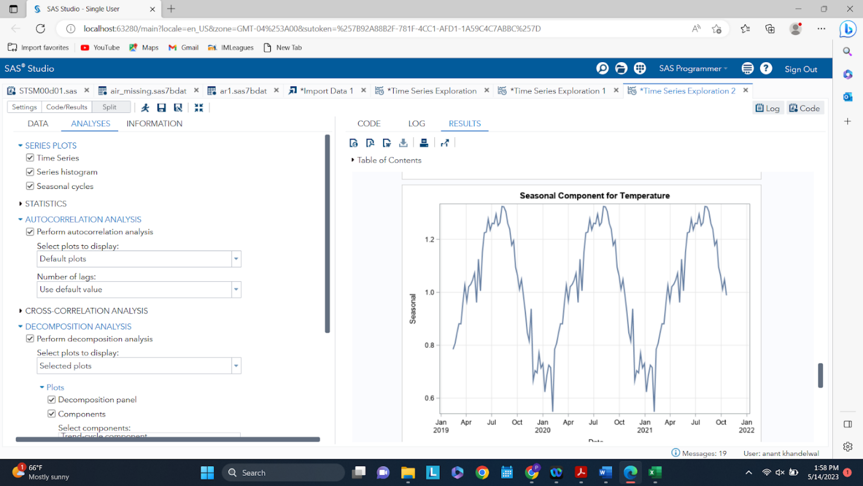

A very clear and distinct pattern or seasonality is depicted in this component plot. Therefore, it can be concluded that the temperature plot consists of only a seasonal component.

Fig. 10 - Irregular Component of Temperature

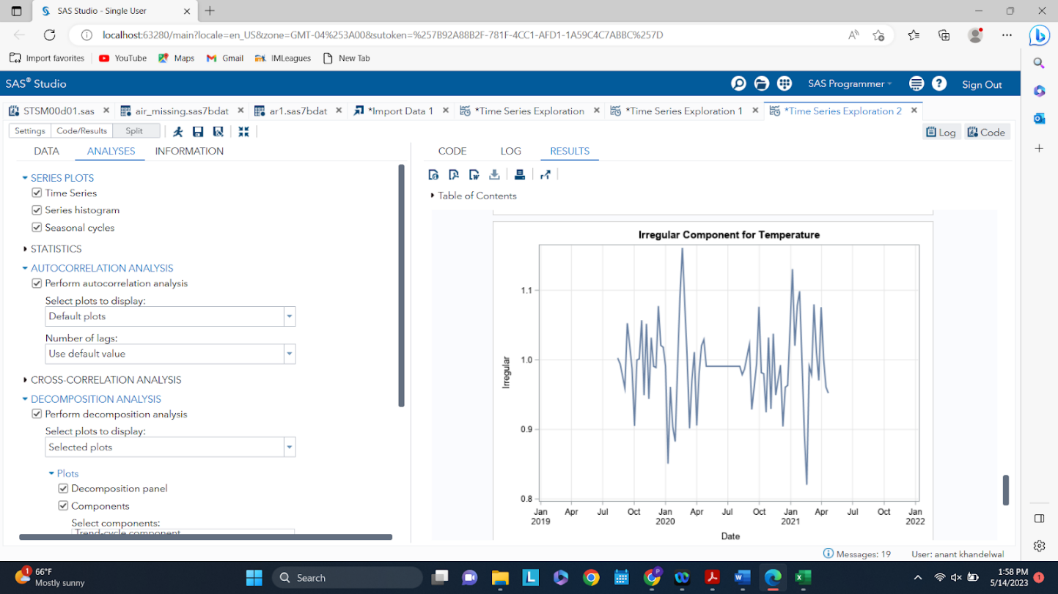

Finally, looking at the irregular component for temperature, it can be seen that it is indeed quite random and no patterns emerge.

Fig. 11 - Correlations for Temperature

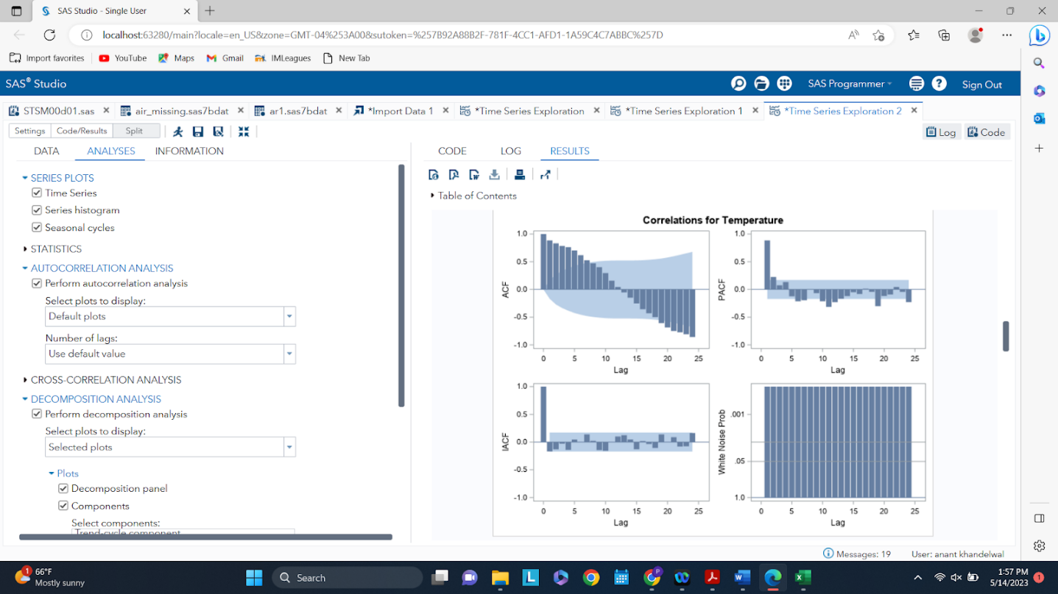

Lastly, examining the ACF, PACF, IACF, and the White Noise Test, a signal is present in the temperature variable of the data Therefore, the seasonal component does capture a good representation of the time series. Further, pre-whitening analysis will have to be conducted to see if temperature has ordinary or dynamic regressors to the dependent variable.

Fig. 12 - Fuel Price Time Series

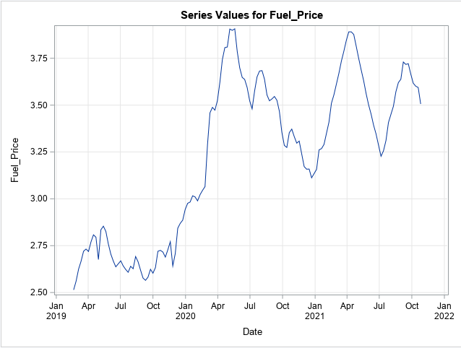

From the plot above, it can be seen that this is a general trend. But no explicit seasonal pattern is seen. Hence, it can be concluded that fuel price is a time series for the given time period of three years from 2019 - 2022. Below are the decompositions of the time series for fuel prices to further examine the components.

Fig. 13 - Trend Component of Fuel Price

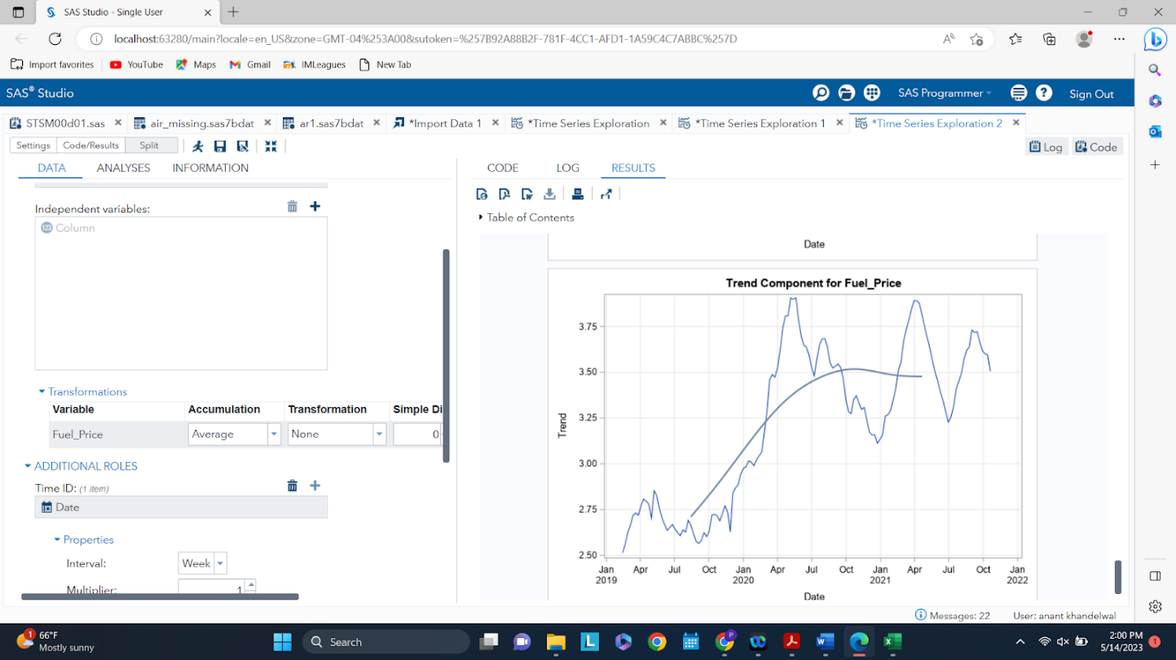

A very clear trend component is seen for fuel price. It is an increasing trend from 2019 - 2023, with a slight drop at the end. Overall, the fuel prices are increasing for the given time period of this analysis.

Fig. 14 - Seasonality Component of Fuel Price

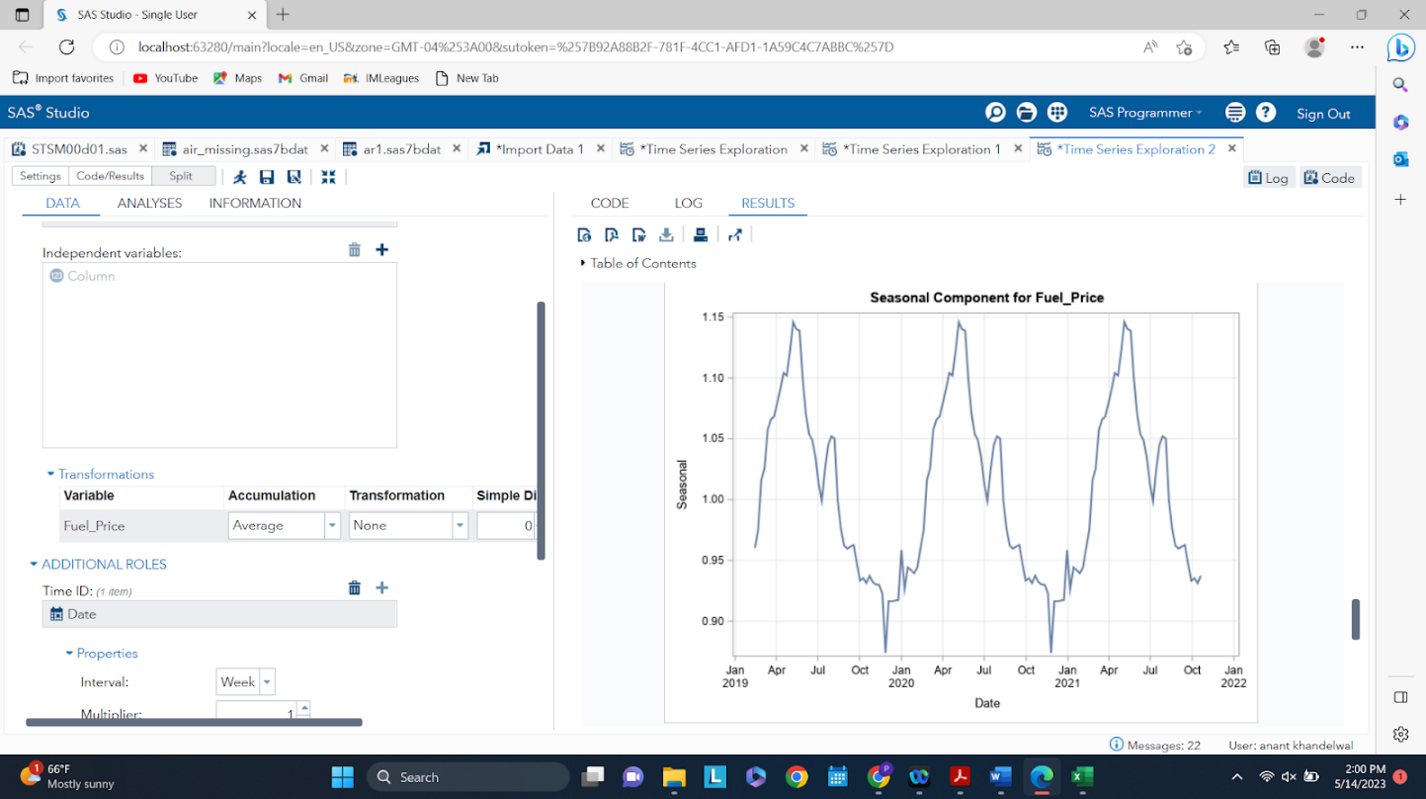

A very clear and distinct pattern or seasonality is depicted in this component plot. Therefore, it can be concluded that the fuel prices plot consists of a seasonal component for the given time period as well.

Fig. 15 - Irregular Component of Fuel Price

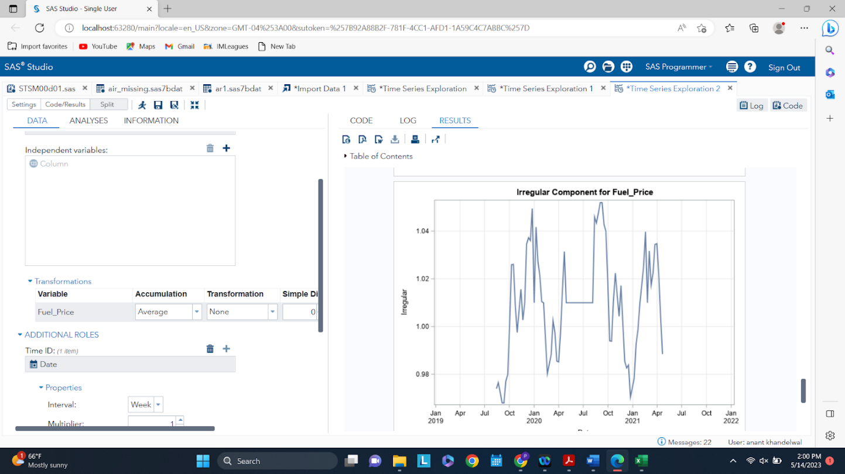

Finally, looking at the irregular component for fuel prices, it can be seen that it is indeed quite random and no patterns emerge.

Fig 16. - Correlations for Fuel Price

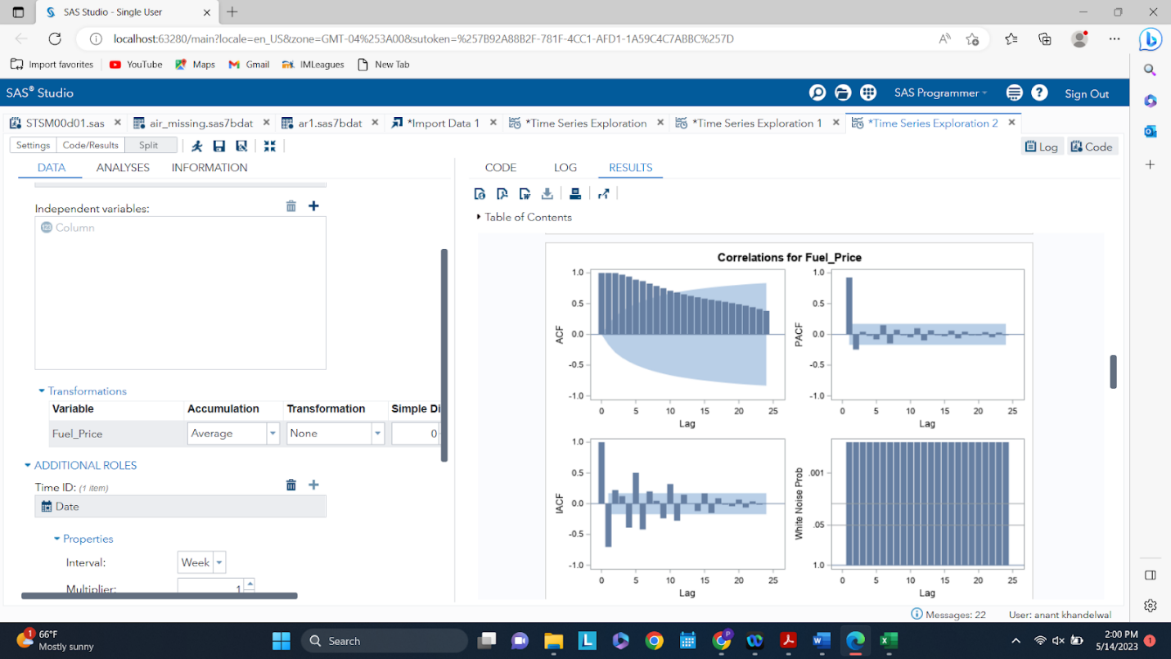

Lastly, examining the ACF, PACF, IACF, and the White Noise Test, a signal is present in the fuel price variable of the data Therefore, the trend and seasonal components do capture a good representation of the time series. Further, pre-whitening analysis will have to be conducted to see if temperature has ordinary or dynamic regressors to the dependent variable.

Fig. 17 - CPI Time Series

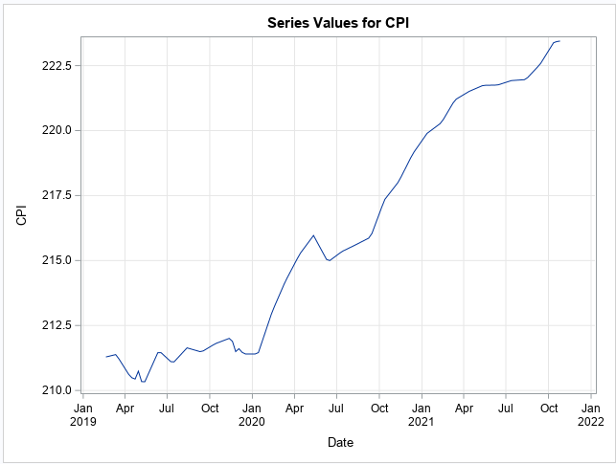

From the plot above, it can be seen that there is a general trend. But no explicit seasonal pattern is seen. Hence, it can be concluded that CPI is a time series for the given time period of three years from 2019 - 2022. CPI is the consumer price index, meaning that for the given time period, items are getting more expensive as compared to the previous year or baseline. Below are the decompositions of the time series for CPI to further examine the components.

Fig. 18 - Trend Component of CPI

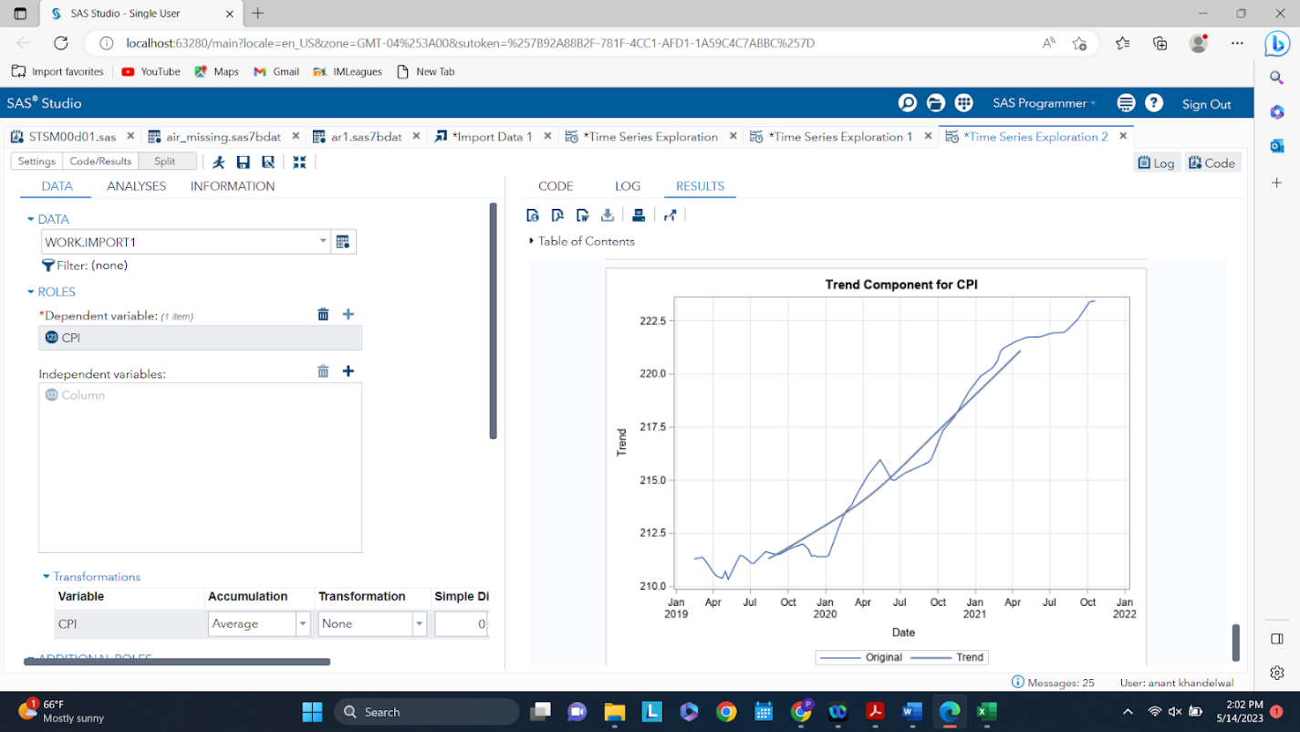

A very clear trend component is seen for CPI. It is an increasing trend from 2019 - 2023.

Fig. 19 - Seasonality Component of CPI

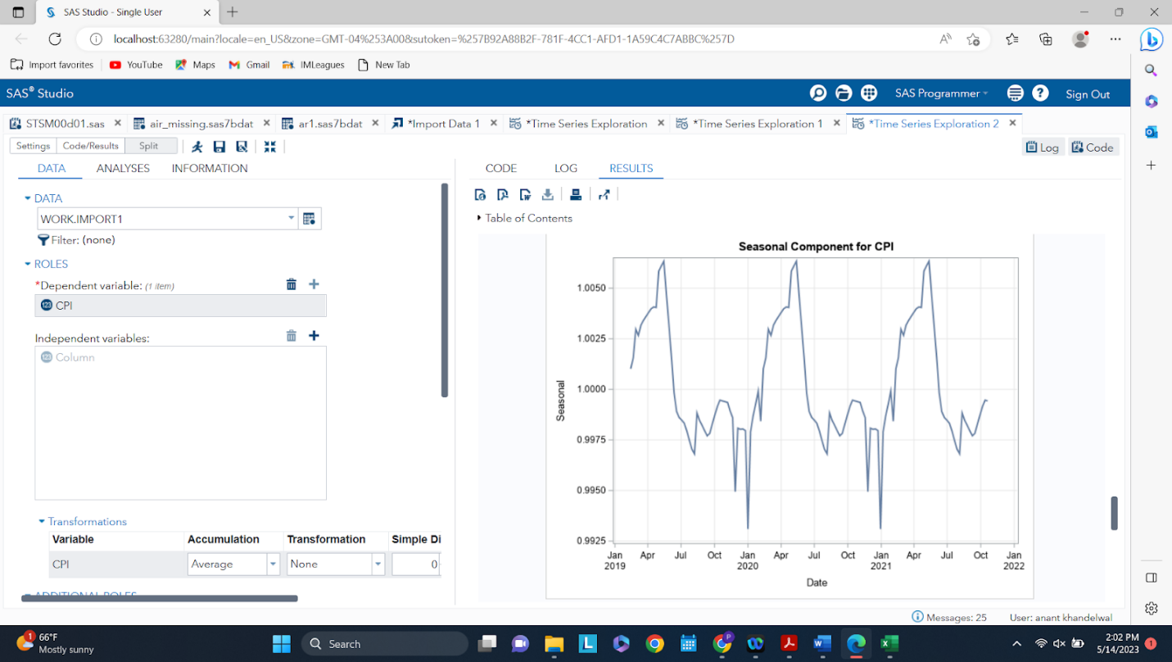

A very clear and distinct pattern or seasonality is depicted in this component plot. Therefore, it can be concluded that the CPI  plot consists of a seasonal component for the given time period as well.

Fig. 20 - Irregular Component of CPI

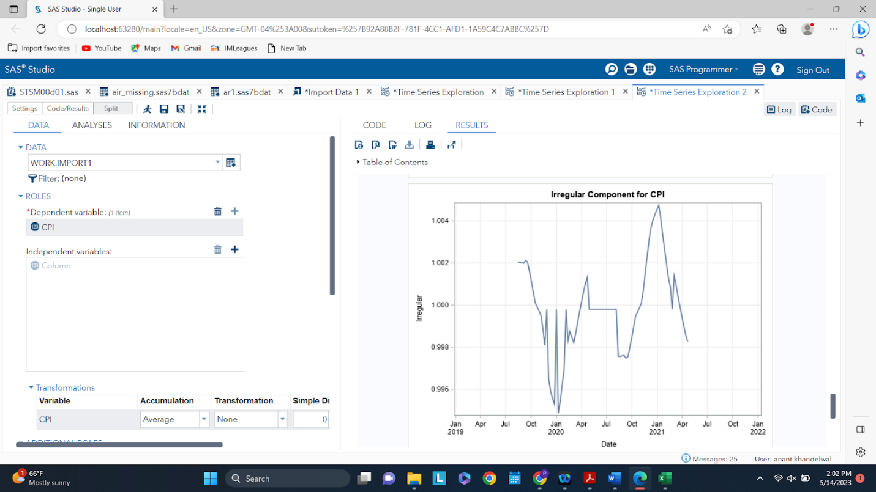

Finally, looking at the irregular component for CPI, it can be seen that it is indeed quite random and no patterns emerge.

Fig. 21 - Correlations for CPI

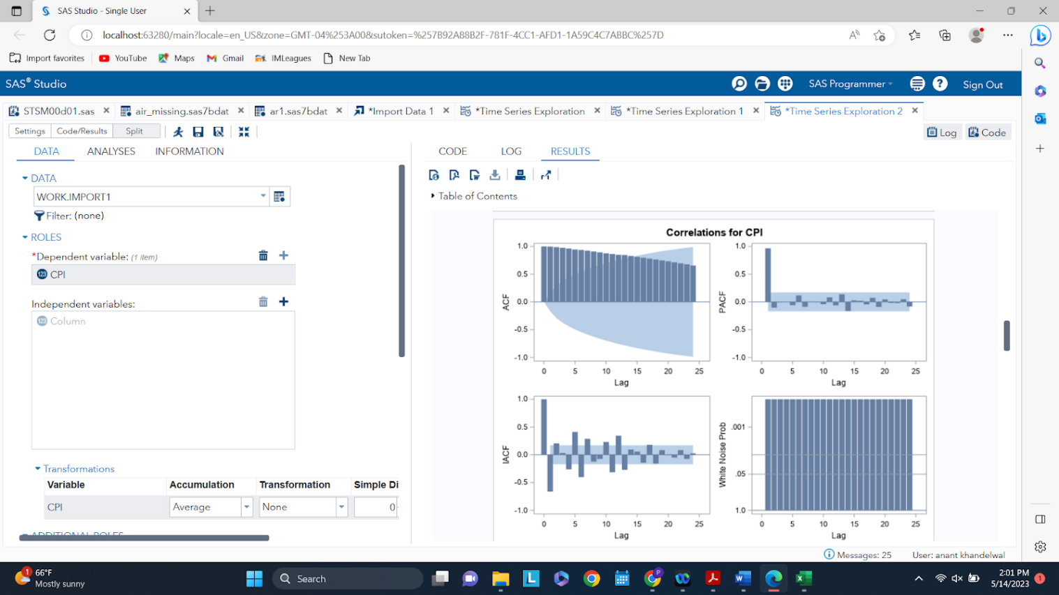

Lastly, examining the ACF, PACF, IACF, and the White Noise Test, a signal is present in the CPI variable of the data Therefore, the trend and seasonal components do capture a good representation of the time series. Further, pre-whitening analysis will have to be conducted to see if temperature has ordinary or dynamic regressors to the dependent variable.

Fig. 22 - Unemployment Time Series

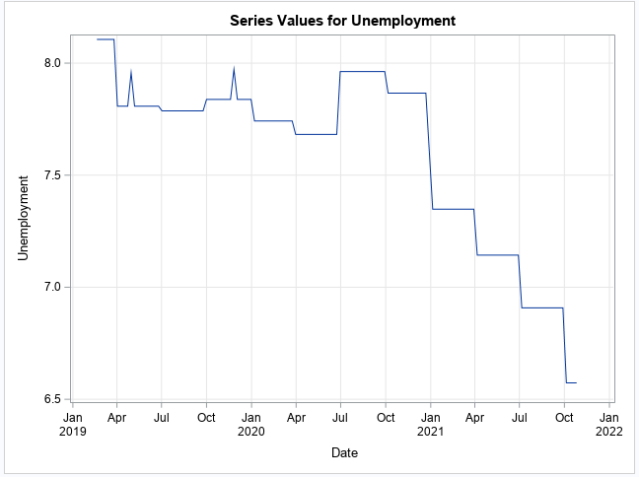

From the plot above, it can be seen that there is a general declining trend. But no explicit seasonal pattern is seen. Hence, it can be concluded that unemployment is a time series for the given time period of three years from 2019 - 2022. Unemployment is a macroeconomic measure of how an economy is doing, with a decreasing unemployment rate, the economy is generally doing well, meaning there is more disposable income and therefore more cash injections into the economy. This will be a very important independent variable for our analysis and below are the decompositions of the time series for unemployment to further examine the components.

Fig. 23 - Trend Component of Unemployment

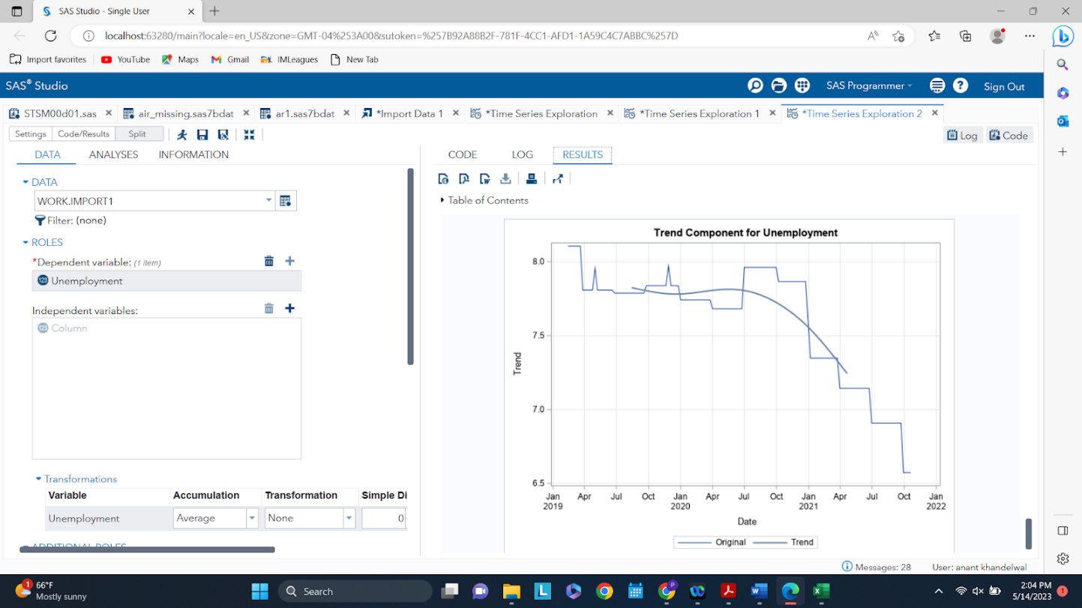

A very clear trend component is seen for unemployment. It is a decreasing trend from 2019 - 2023.

Fig. 24 - Seasonality Component of Unemployment

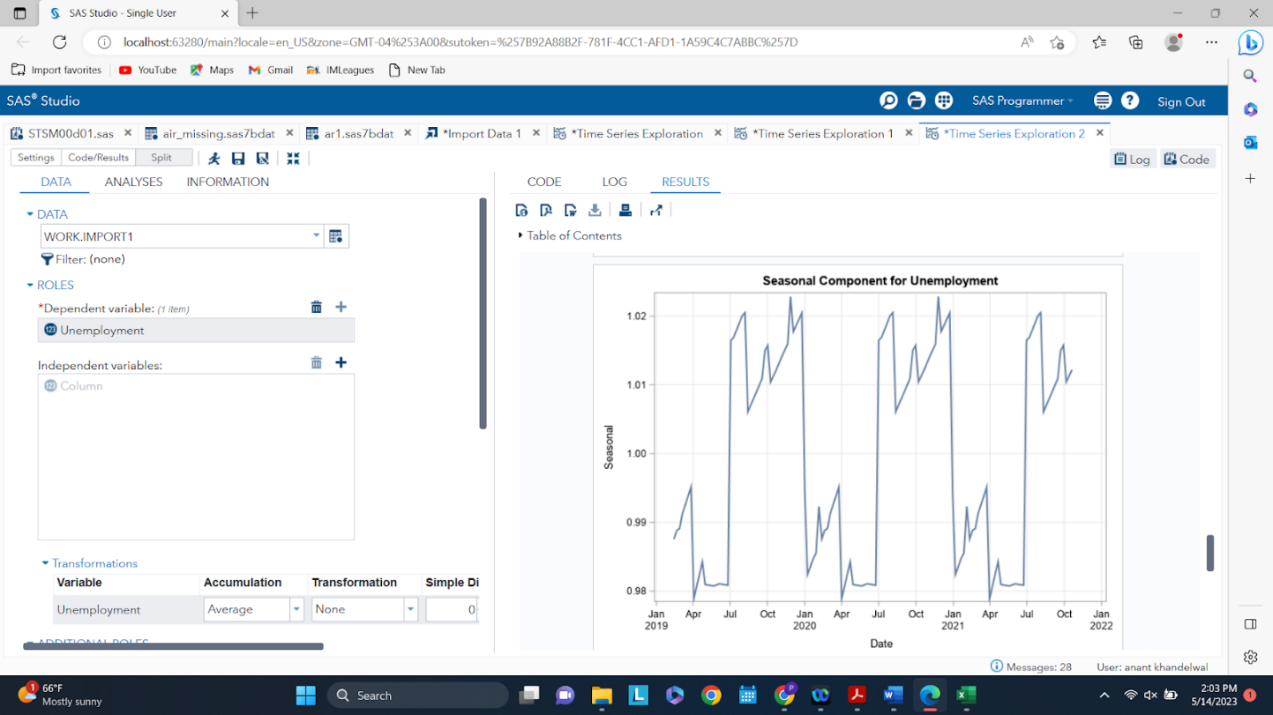

A distinct but not convincing pattern is seen for unemployment. While the pattern is repeating, it seems to be jumping from high to low to high values rather than having some smoothness to them. But a further look into this during modeling will help identify if a seasonal component exists in this time series.

Fig. 25 - Irregular Component of Unemployment

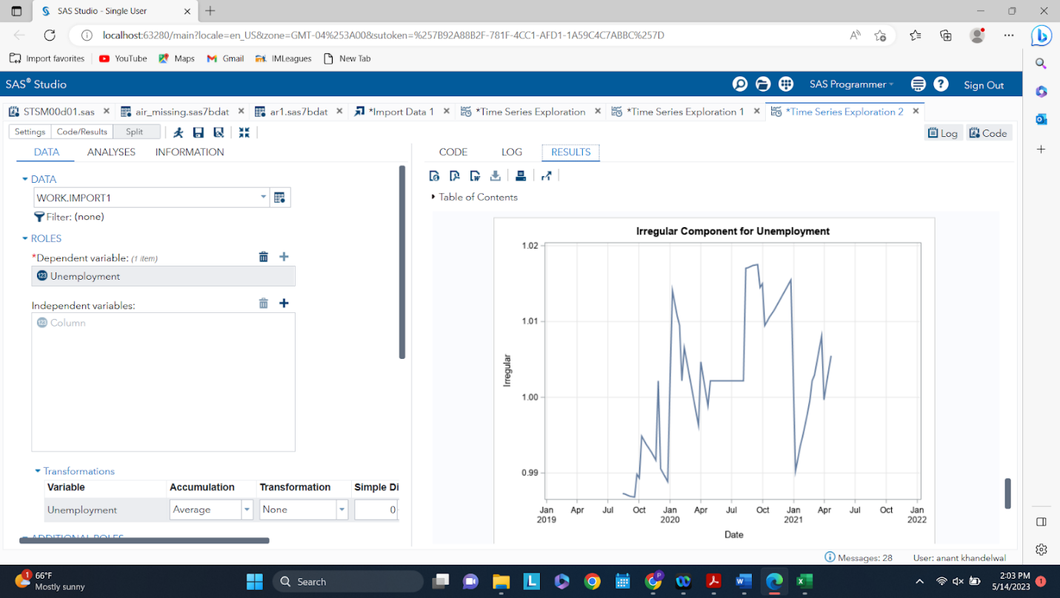

Finally, looking at the irregular component for unemployment, it can be seen that it is indeed quite random and no patterns emerge.

Fig 26. - Correlations for Unemployment

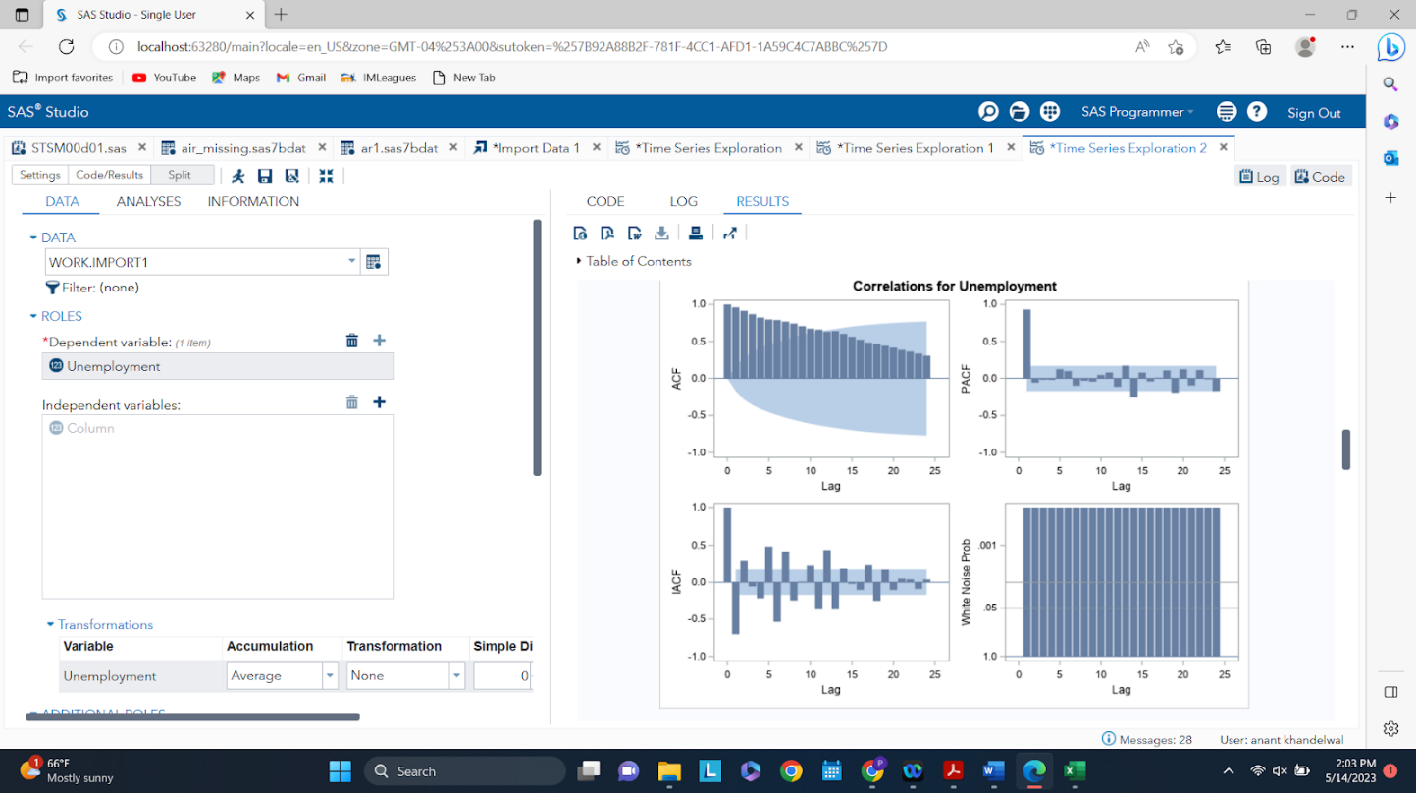

Lastly, examining the ACF, PACF, IACF, and the White Noise Test, a signal is present in the unemployment variable of the data. Therefore, the trend and seasonal components do capture a good representation of the time series. Further, pre-whitening analysis will have to be conducted to see if temperature has ordinary or dynamic regressors to the dependent variable.

Fig. 27 - IsHoliday Time Series

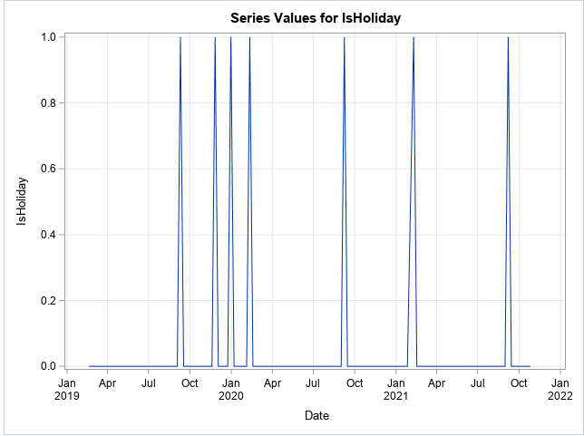

IsHoliday is a categorical independent variable that gives insight into whether or not a day is a holiday or not in the given time period 2019 - 2023. By looking at the plot above, it can be seen quite clearly that the values only fluctuate between 0 and 1. Therefore, isHoliday is not a time series and will be treated simply as a categorical exogenous variable.

**3.2.2 Pre-Whitening & Cross-Correlations**

After exploring the independent variables, the conclusion was that four of them are indeed time series. Different models were run on each of four independent variables until only white noise is left in the residual correlation plots. This means that the signal is extracted for the independent variables. The plots are shown below and the corresponding model used.

**Temperature - ARMA (1,0)**

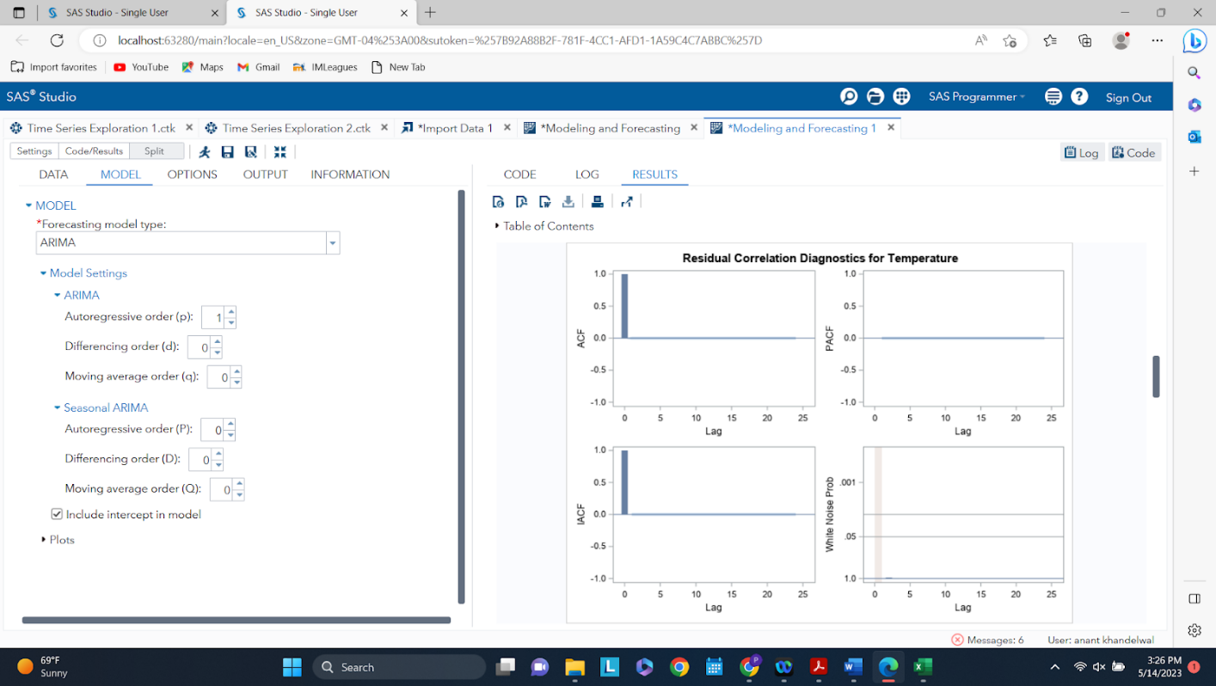

Residuals show that the model ARIMA (1,0) consists of only white noise and therefore the signal is extracted. This is now ready to be used with the dependent variable to check for ordinary and dynamic regressors.

**Fuel Price - ARMA (1,0)**

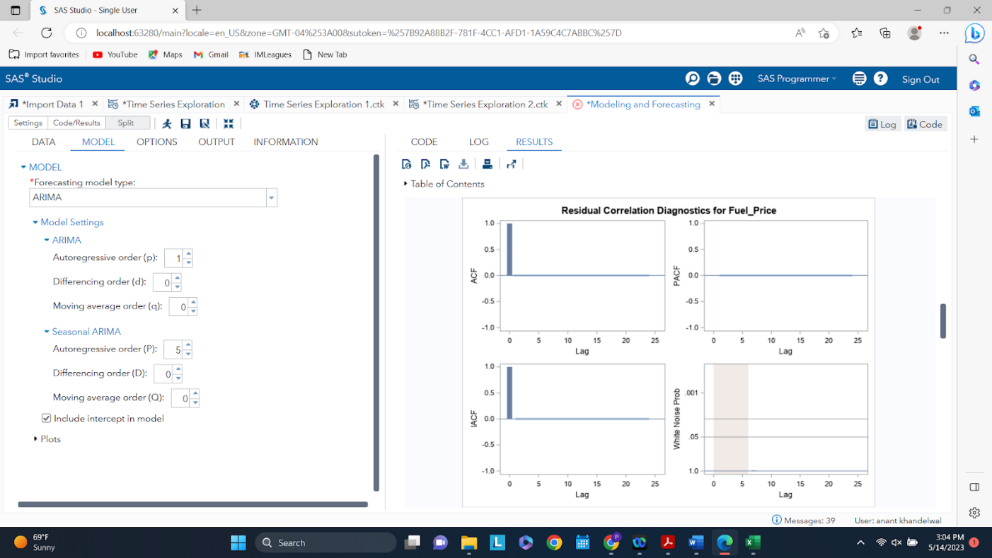

Residuals show that the model ARIMA (1,0) consists of only white noise and therefore the signal is extracted. This is now ready to be used with the dependent variable to check for ordinary and dynamic regressors.

**CPI - ARMA (1,0)**

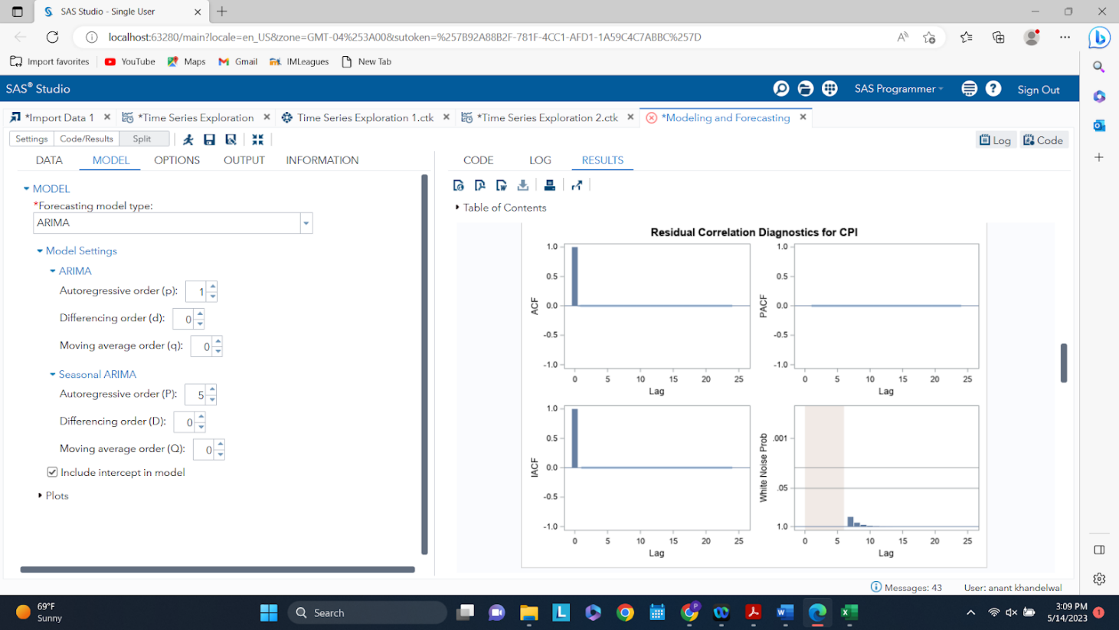

Residuals show that the model ARIMA (1,0) consists of only white noise and therefore the signal is extracted. This is now ready to be used with the dependent variable to check for ordinary and dynamic regressors.

**Unemployment - ARMA (1,0)**

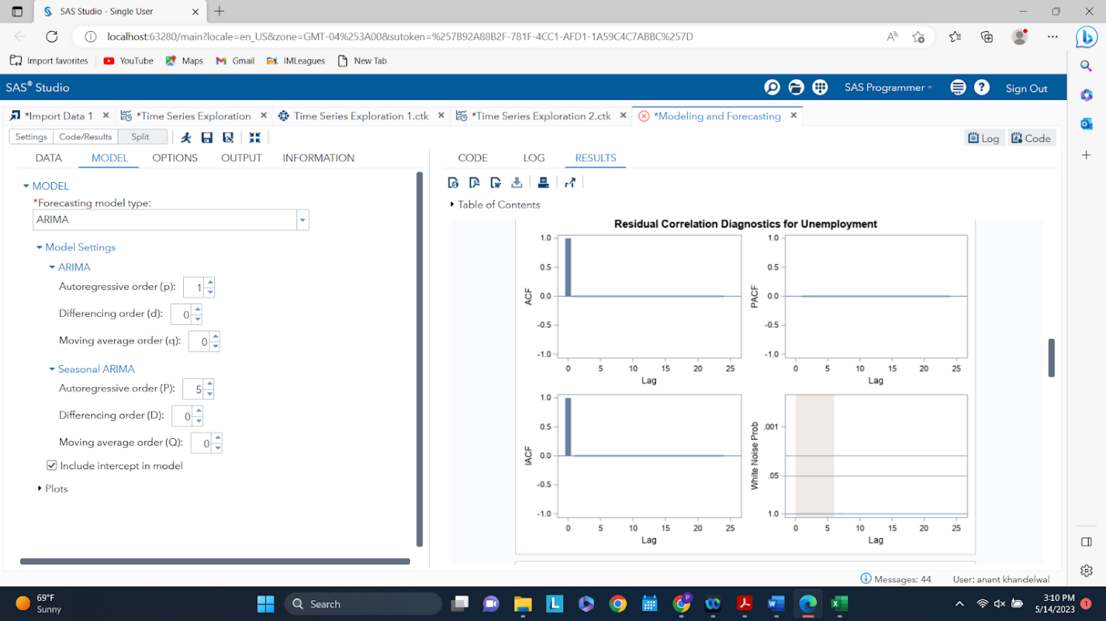

Residuals show that the model ARIMA (1,0) consists of only white noise and therefore the signal is extracted. This is now ready to be used with the dependent variable to check for ordinary and dynamic regressors.

**Now that the independent variables are modeled, it is time to run it on the dependent variable to check the cross-correlations between the two to find if there are any ordinary and/or dynamic regressors or simply lagged effects.**

Plot 1 - Cross-Correlation between Temperature and Aggregated Mean Weekly Sales

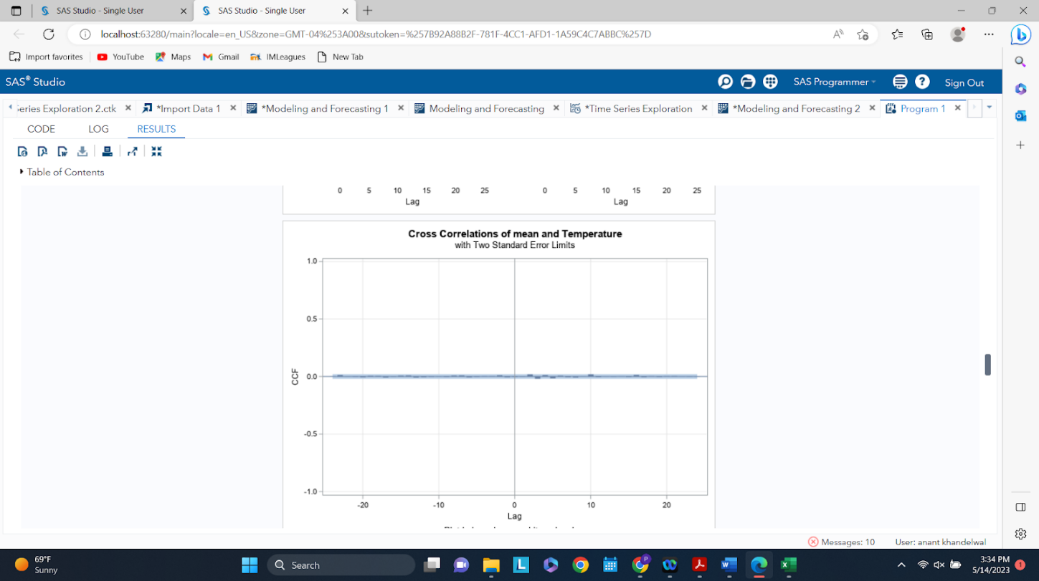

From the cross-correlation plot above, it can be seen that temperature does not have any ordinary or dynamic regressors to the dependent variable. So it can be omitted in our analysis.

Plot 2 - Cross-Correlation between Fuel Price and Aggregated Mean Weekly Sales

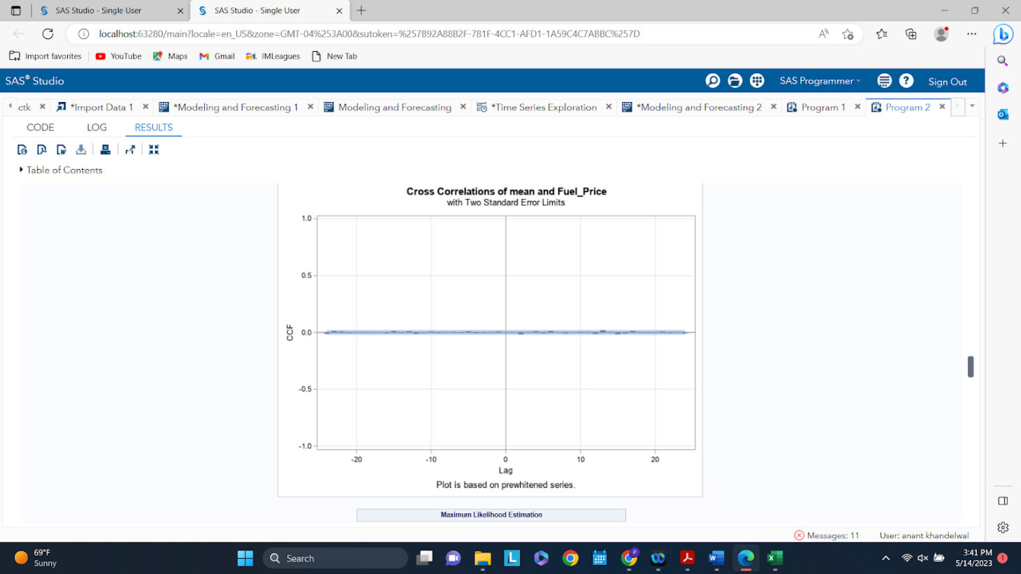

From the cross-correlation plot above, it can be seen that fuel price does not have any ordinary or dynamic regressors to the dependent variable. So it can be omitted in our analysis.

Plot 3 - Cross-Correlation between CPI and Aggregated Mean Weekly Sales

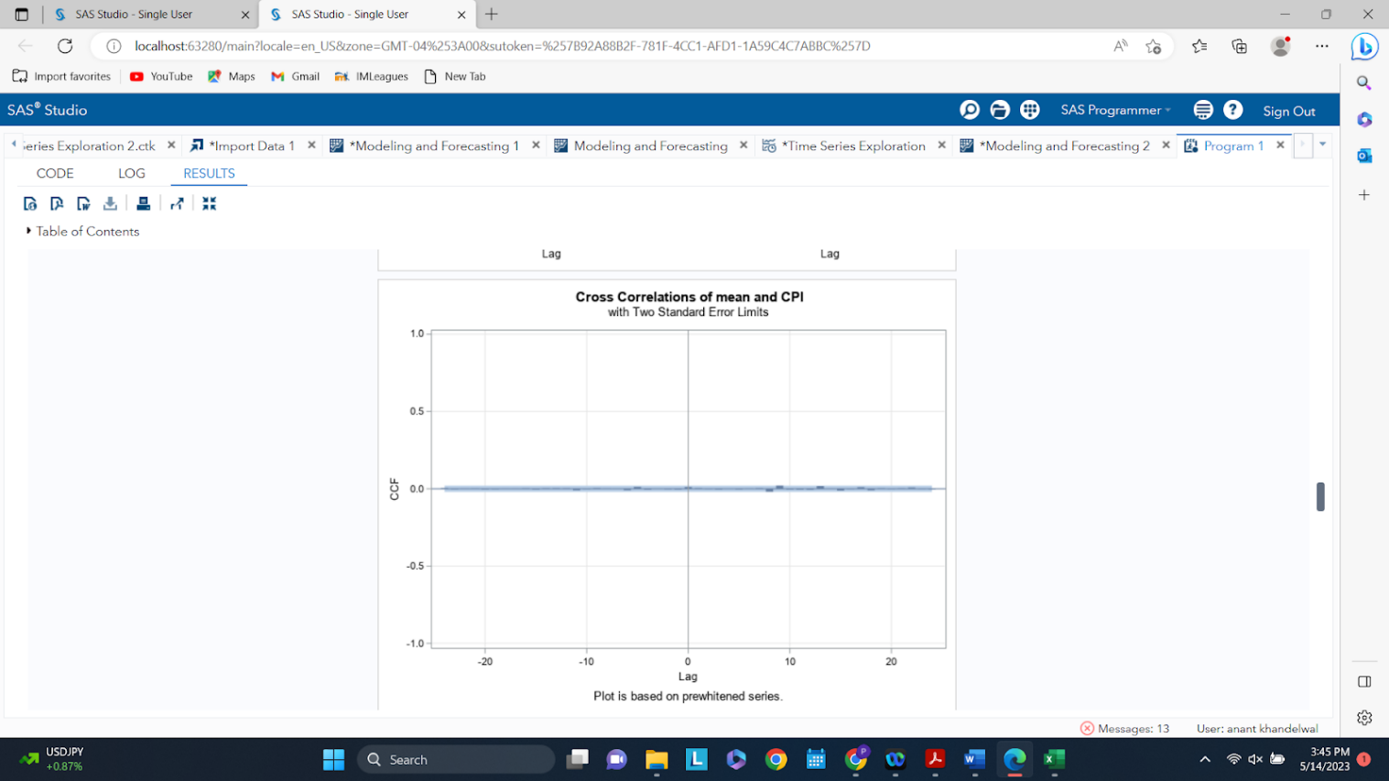

From the cross-correlation plot above, it can be seen that CPI does not have any ordinary or dynamic regressors to the dependent variable. So it can be omitted in our analysis.

Plot 4 - Cross-Correlation between Unemployment and Aggregated Mean Weekly Sales

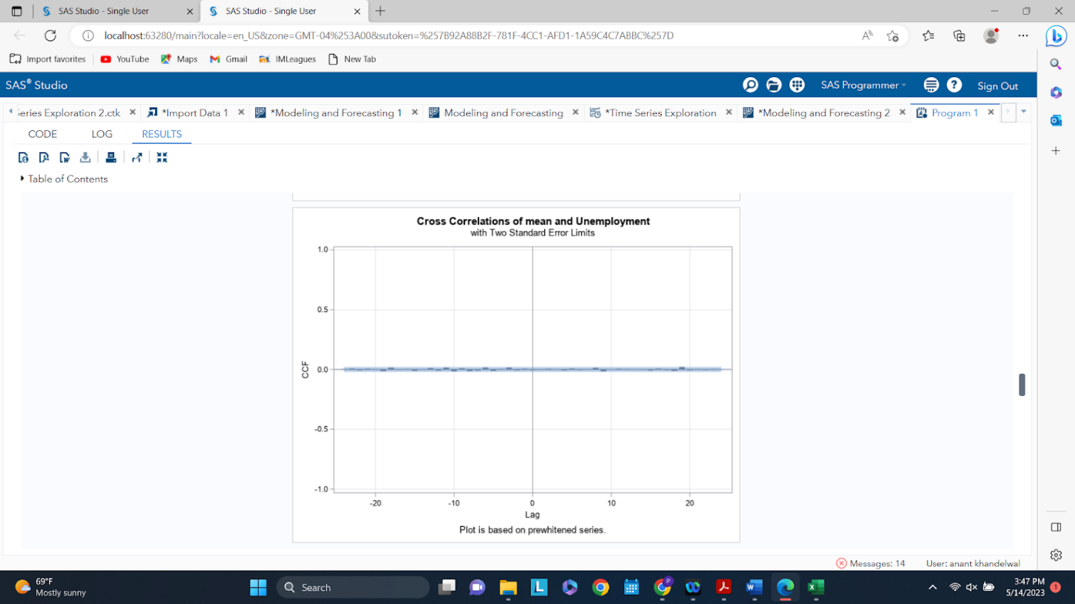

From the cross-correlation plot above, it can be seen that unemployment does not have any ordinary or dynamic regressors to the dependent variable. So it can be omitted in our analysis.

**Therefore, it can be seen that the four independent variables: temperature, fuel price, CPI, and unemployment do not show any cross-correlation with the dependent variable and are statistically insignificant. All spikes are contained within the 95% confidence interval and therefore all four independent variables can be omitted from our analysis.**

**3.3 Checking for stationarity**

Lastly, prior to moving on to modeling and forecasting the aggregate weekly sales for the amazon store. First, the Augmented Dickey-Fuller (ADF) test must be used to check for stationarity of the dataset. This is a statistical test to verify that the data is stationary, which allows the use of ARIMA models that are very powerful and accurate. The ADF test is as follows: the null hypothesis is that the data is not stationary and the alternative hypothesis is that the data set is stationary. Therefore if the p-values for Pr< Rho  and Pr > F are significant, ie. < 0.05, the data is stationary.

Stationary Test Table

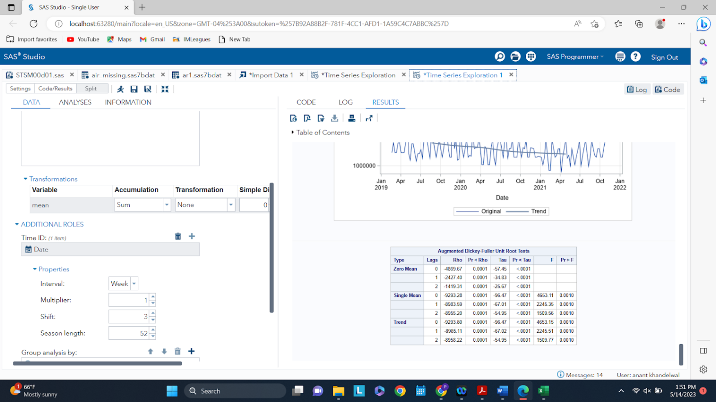

The dependent variable clearly shows a trend and hence the focus should be on rows corresponding to the ‘Trend’ type. Examining these rows, it is seen that the Pr< Rho  and Pr > F are 0.0001 and 0.0010, respectively. This means that the test is significant and the data is stationary, therefore ARIMA models can be used for modeling and forecasting purposes.

1. **Modeling and forecasting:**

There were 2 important factors to be considered before kick starting modeling:

1. Variables or parameters to be considered for model generation.
2. Understanding trend and seasonality in data to ensure correct models are used and optimized.

**4.1 Finalizing key independent variables:**

To start creating models, it was critical to select the variables to be used to generate forecasts that would help predict sales trends based on key input parameters. Based on the variables explored in the previous section, we concluded on using the below set of variables:

1. Stochastic variables (*Numeric*):
   1. Temperature
   2. CPI
   3. Unemployment
   4. Fuel price
2. Deterministic variables (*Categorical*) :
   1. IsHoliday

**4.2 Determining right set of models:**

Amazon data set explored in the initial section shows there is definite seasonality in sales of store 1. Also, the trend graph shows there is a declining trend from 2019 to 2021 for the store considering sales for all the departments aggregated.

Also, the correlation graph shows that the data is not white noise and hence there is some systematic variation that can be captured using the models. Here, the PACF and IACP do who some spikes, thought not very significant. Hence, we tried to consider different ARIMA models to capture auto-regressive and moving average models.

**4.3 Modeling:**

There were 2 sets of models generated – ARIMA and ARIMAX using a **HOLDOUT** sample of **12 months** and a **forecast** of **24 months** as below:

**4.3.1 ARIMA:**

**Model 1: ARIMA(0,2):**

The first model created was an ARIMA model with parameters as below:

p = 0

q = 2

With the same, below were the outputs:

1. **Correlation for mean**:

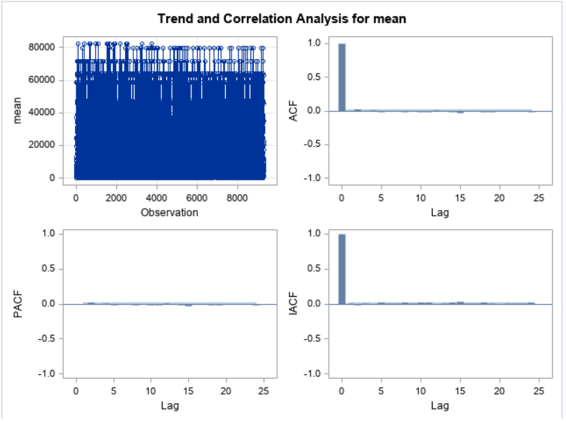

Through ACF graph, it is evident that there is no autocorrelation. Also, there are no spikes in the PACF and the IACF graphs.

1. **Residual plots:**

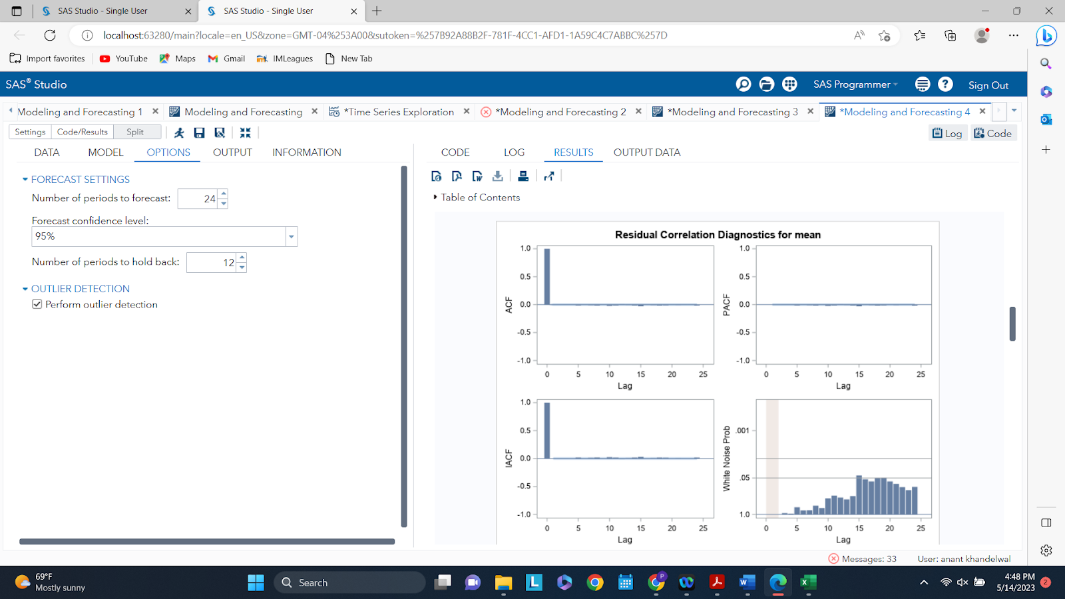

The results show that the white noise test fails for the residuals with some spikes above the threshold and hence, the model is not able to capture all the systematic variation existing in the dataset well. Also, there is no auto-correlation that exists in the residual plot and hence is great.

1. **Residual normality check:**

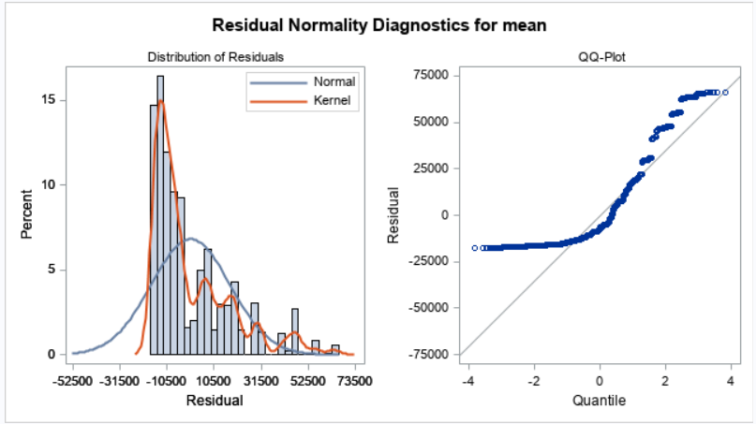

The residual graph indicates that the residuals are not normal but right skewed. Ideally, we would expect residuals to show normality and hence this model shows some skewness against that.

1. **Autocorrelation check for residuals:**

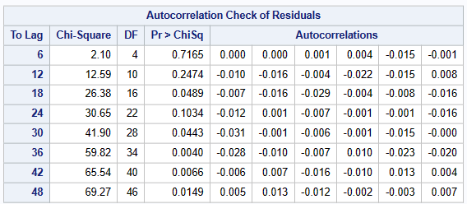

As indicated in the graph, the table above also indicates that there is no auto-correlation for the residuals and all values are insignificant.

1. **Parameter estimates:**

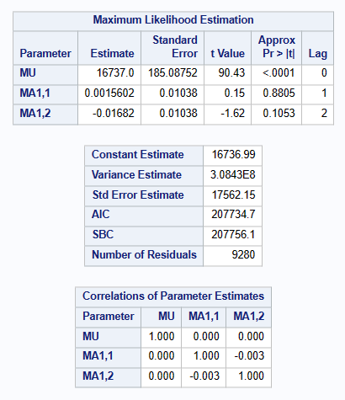

The parameter estimates for MA1 at lag 1 and MA1 at lag 2 are large as they are above the threshold of 0.001 and hence clearly indicate that the model is not able to predict the sales trends well.

1. **Model and forecast outputs:**

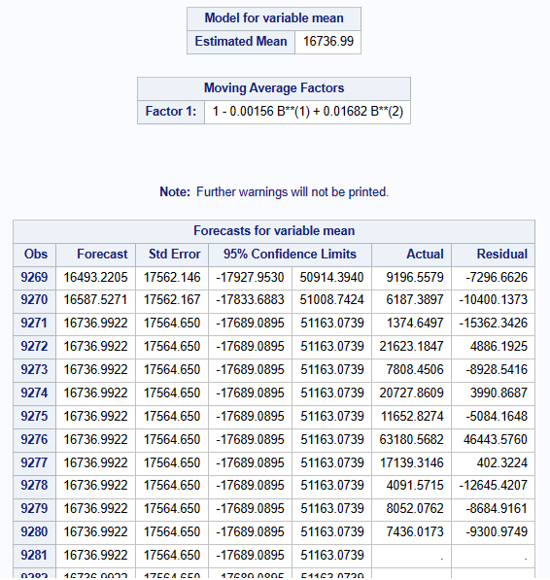

The forecast is shown for 12 months as that is the hold out period and residual is calculated only for that duration.

**4.3.2 ARIMAX:**

**Model 2: ARIMAX(0,0)**

The second model was created using ARIMAX and had below parameters:

p = 0

q = 0

With the same, below were the outputs:

1. **Correlation for mean**:

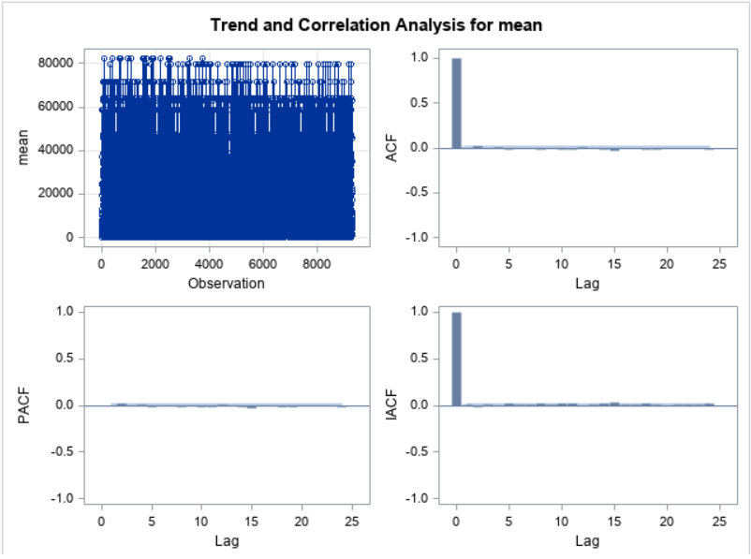

Through ACF graph, it is evident that there is no autocorrelation. Also, there are extremely small spikes in the PACF and the IACF graphs.

1. **Residual plots:**

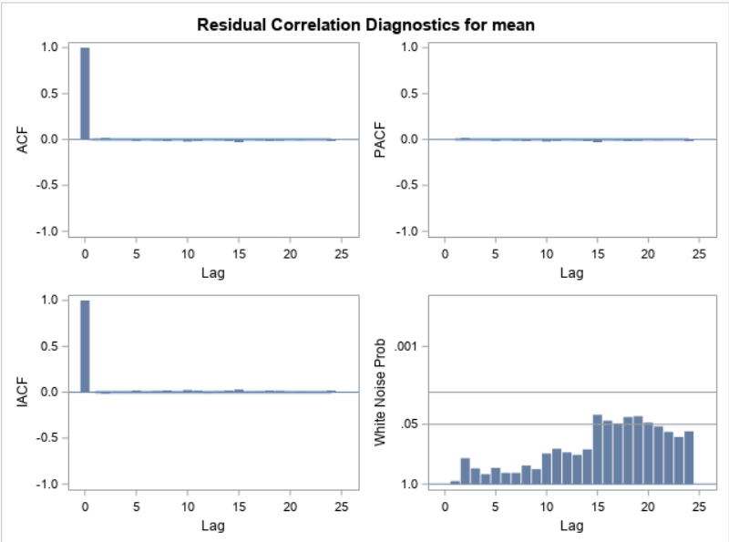

The results show that the white noise test fails for the residuals with some spikes above the threshold and hence, the model is not able to capture all the systematic variation existing in the dataset well. Also, there is no auto-correlation that exists in the residual plot and hence is great.

1. **Residual normality check:**

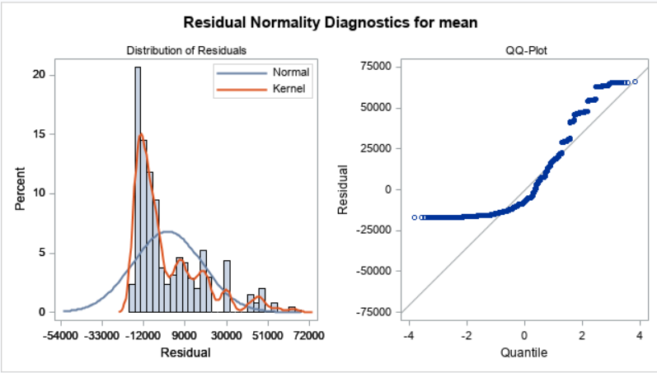

The above plot indicates that the residual graph again is not normal and shows right skewness and kurtosis.

1. **Autocorrelation check for residuals:**

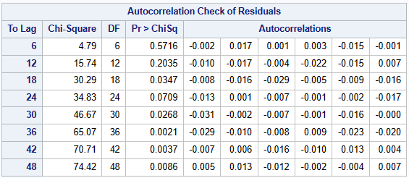

The above table indicates that there is barely any auto – correlation existing amongst the residuals and hence is great.

1. **Parameter estimates:**

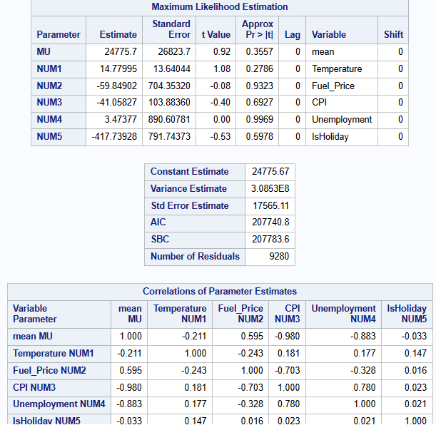

The parameter estimates indicate high values for the independent variables and hence indicate that the model needs to be fine-tuned further to generate better sales forecasts.

1. **Model and forecast outputs:**

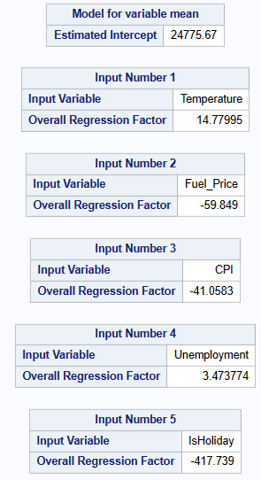

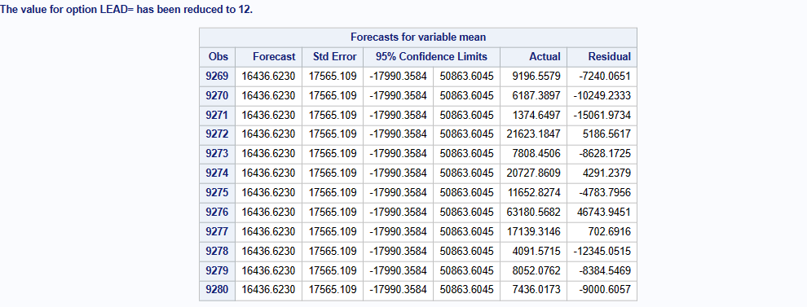

The forecast is shown for 12 months as that is the hold out period and residual is calculated only for that duration.

**Model 3: ARIMAX(1,0)**

The third model was created using ARIMAX and had below parameters:

p = 1

q = 0

With the same, below were the outputs:

1. **Correlation for mean**:

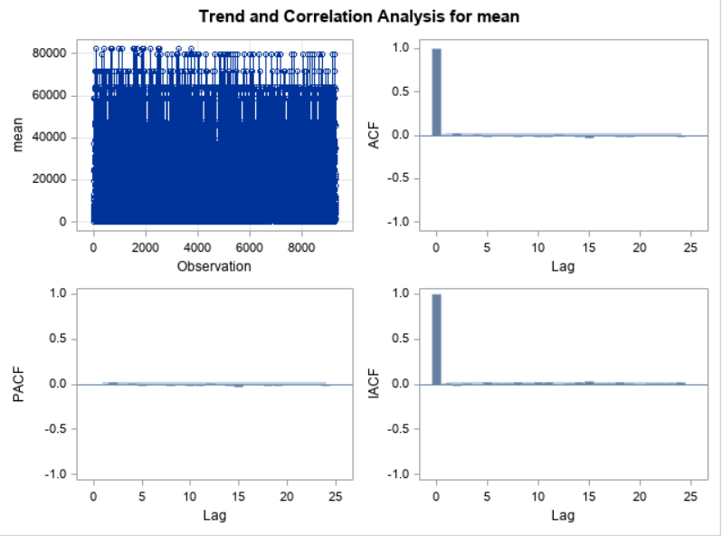

Through ACF graph, it is evident that there is no autocorrelation. Also, there are extremely small spikes in the PACF and the IACF graphs.

1. **Residual plots:**

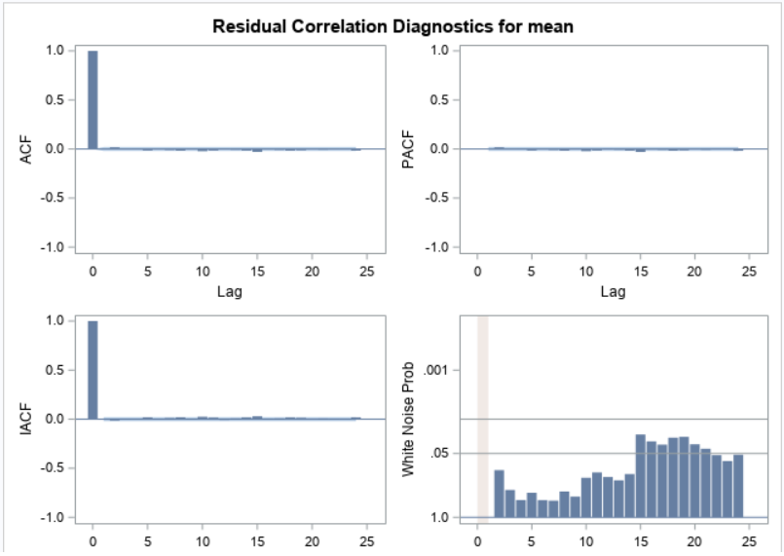

The results show that the white noise test fails for the residuals with some spikes above the threshold and hence, the model is not able to capture all the systematic variation existing in the dataset well. Also, there is no autocorrelation that exists in the residual plot and hence is great.

1. **Residual normality check:**

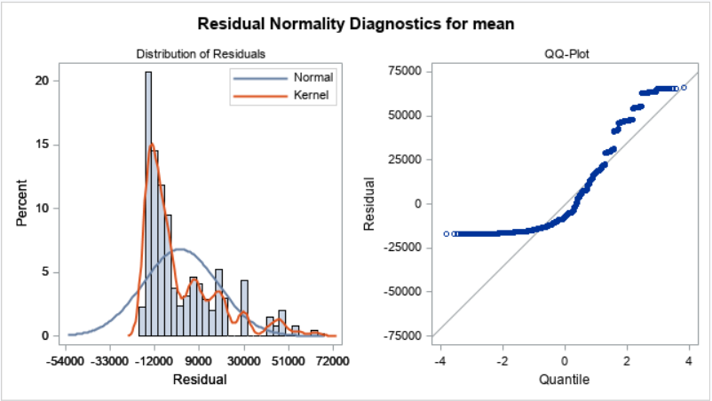

The above plot indicates that the residual graph again is not normal and shows right skewness and kurtosis.

1. **Autocorrelation check for residuals:**

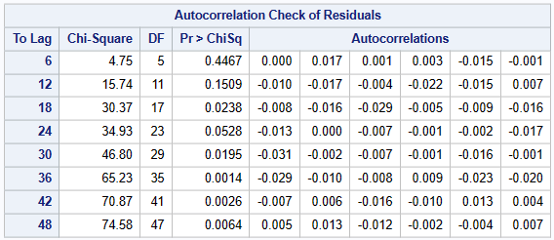

The above table indicates that there is barely any auto – correlation existing amongst the residuals and hence is great.

1. **Parameter estimates:**

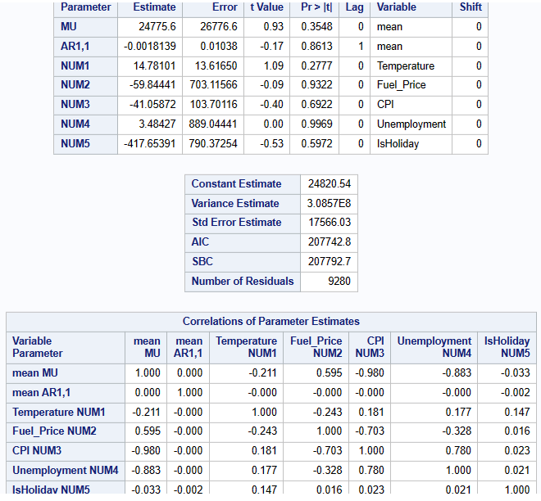

The parameter estimates indicate high values for the independent variables (>0.001) and hence indicate that the model needs to be fine-tuned further to generate better sales forecasts.

1. **Model and forecast outputs:**

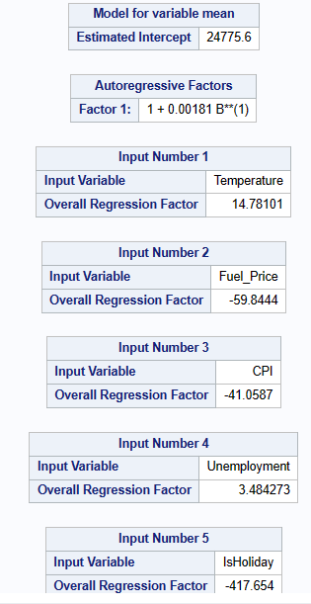

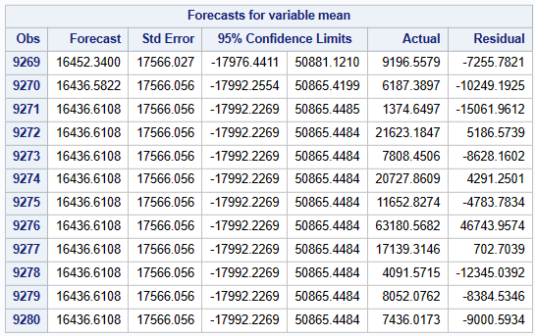

The forecast is shown for 12 months as that is the hold out period and residual is calculated only for that duration.

**Model 4: ARIMAX(0,1)**

The third model was created using ARIMAX and had below parameters:

p = 0

q = 1

With the same, below were the outputs:

1. **Correlation for mean**:

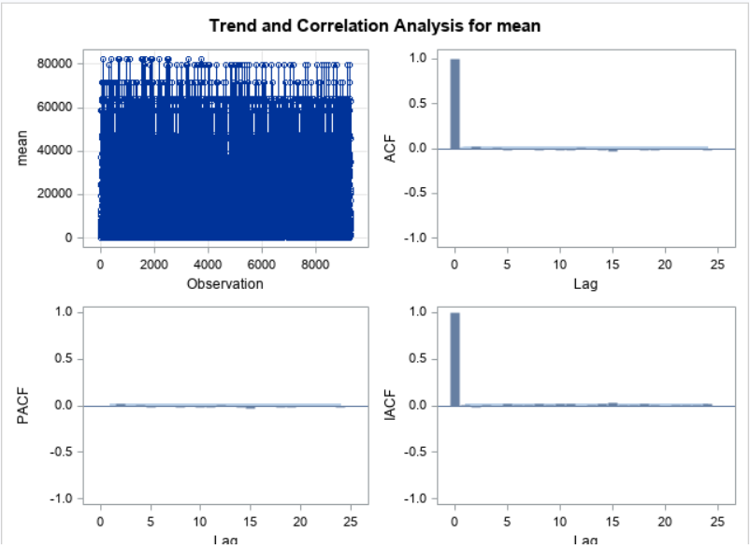

Through ACF graph, it is evident that there is no autocorrelation. Also, there are extremely small spikes in the PACF and the IACF graphs.

1. **Residual plots:**

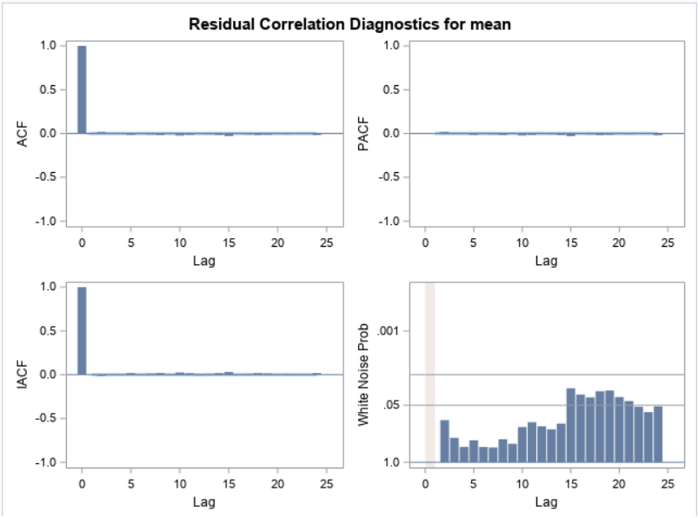

The results show that the white noise test fails for the residuals with some spikes above the threshold and hence, the model is not able to capture all the systematic variation existing in the dataset well. Also, there is no autocorrelation that exists in the residual plot and hence is great.

1. **Residual normality check:**

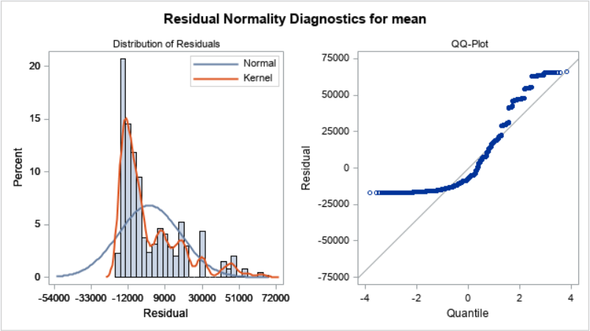

The above plot indicates that the residual graph again is not normal and shows right skewness and kurtosis.

1. **Autocorrelation check for residuals:**

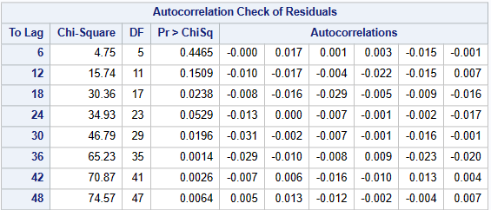

The above table indicates that there is barely any auto – correlation existing amongst the residuals and hence is great.

1. **Parameter estimates:**

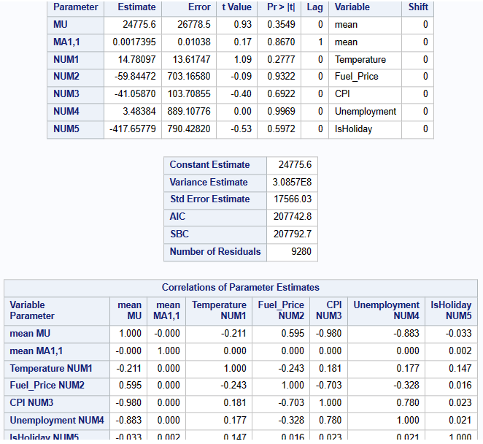

The parameter estimates indicate high values for the independent variables (>0.001) and hence indicate that the model needs to be fine-tuned further to generate better sales forecasts.

1. **Model and forecast outputs:**

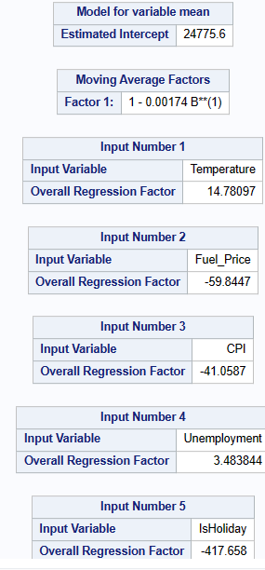

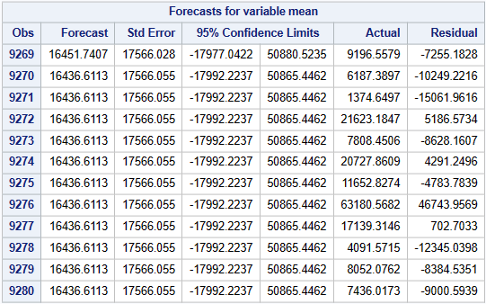

The forecast is shown for 12 months as that is the hold out period and residual is calculated only for that duration.

**Model 5: ARIMAX(1,1)**

The fourth model was created using ARIMAX and had below parameters:

p = 1

q = 1

With the same, below were the outputs:

1. **Correlation for mean**:

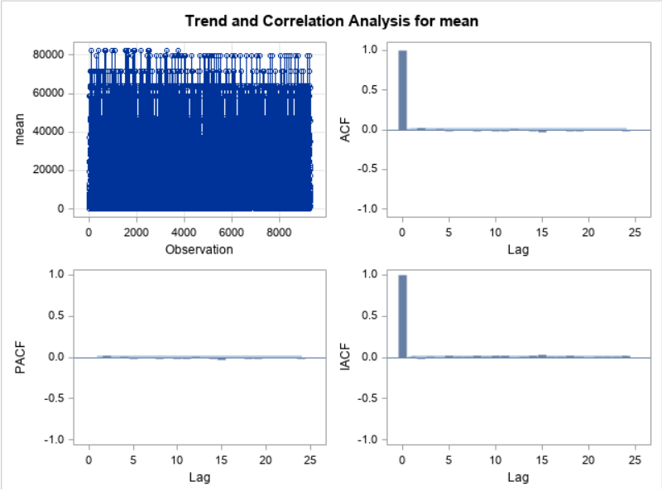

Through ACF graph, it is evident that there is no autocorrelation. Also, there are extremely small spikes in the PACF and the IACF graphs.

1. **Residual plots:**

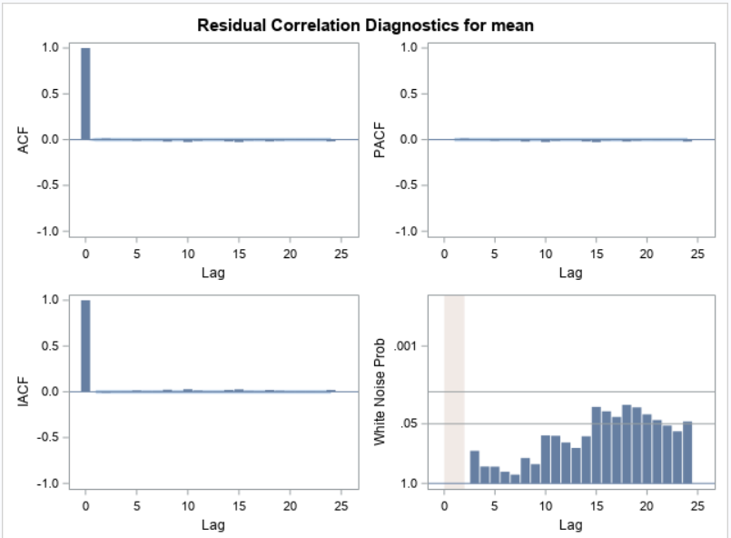

The results show that the white noise test fails for the residuals with some spikes above the threshold and hence, the model is not able to capture all the systematic variation existing in the dataset well. Also, there is no autocorrelation that exists in the residual plot and hence is great.

1. **Residual normality check:**

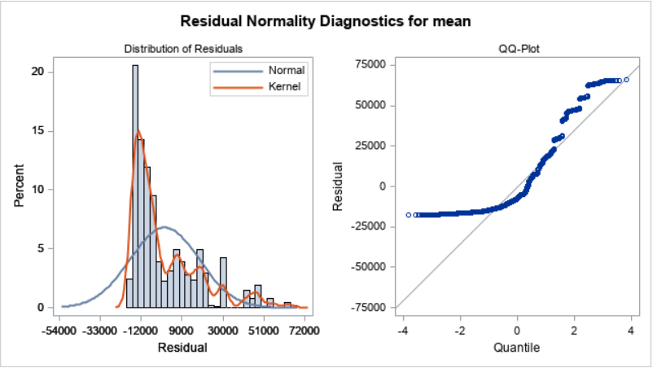

The above plot indicates that the residual graph again is not normal and shows right skewness and kurtosis.

1. **Autocorrelation check for residuals:**

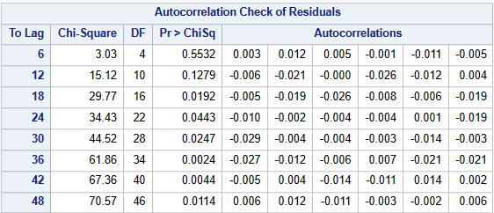

The above table indicates that there is barely any auto – correlation existing amongst the residuals and hence is great.

1. **Parameter estimates:**

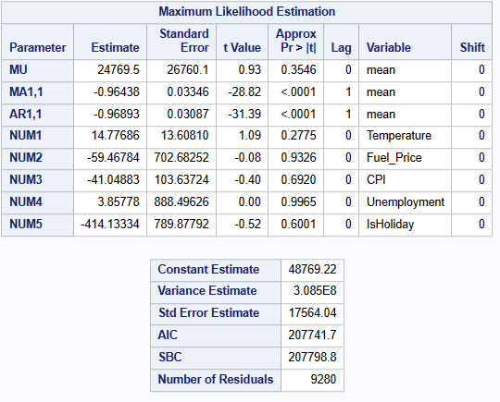

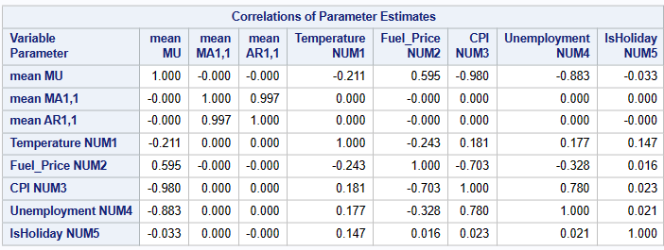

The parameter estimates indicate low values for the independent variables (<0.001) and hence indicate that the model is good to generate sales forecasts.

1. **Model and forecast outputs:**

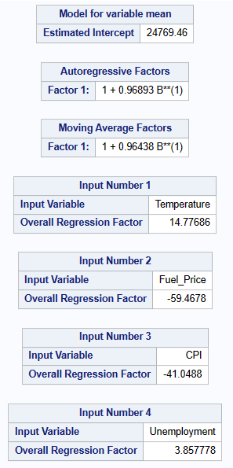

**Model 6: ARIMAX(2,0)**

The fourth model was created using ARIMAX and had below parameters:

p = 2

q = 0

With the same, below were the outputs:

1. **Correlation for mean**:



Through ACF graph, it is evident that there is no autocorrelation. Also, there are extremely small spikes in the PACF and the IACF graphs.

1. **Residual plots:**

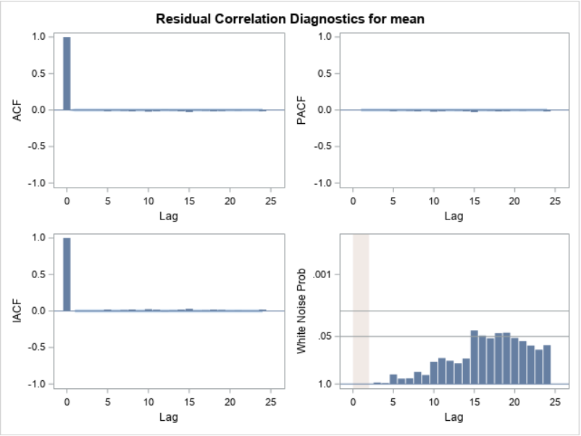

The results show that the white noise test fails for the residuals with some spikes above the threshold and hence, the model is not able to capture all the systematic variation existing in the dataset well. Also, there is no autocorrelation that exists in the residual plot and hence is great.

1. **Residual normality check:**

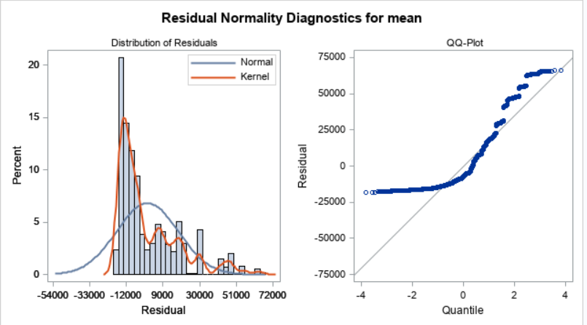

The above plot indicates that the residual graph again is not normal and shows right skewness and kurtosis.

1. **Autocorrelation check for residuals:**

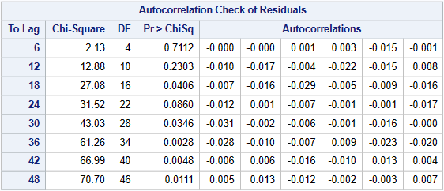

The above table indicates that there is barely any auto – correlation existing amongst the residuals and hence is great.

1. **Parameter estimates:**

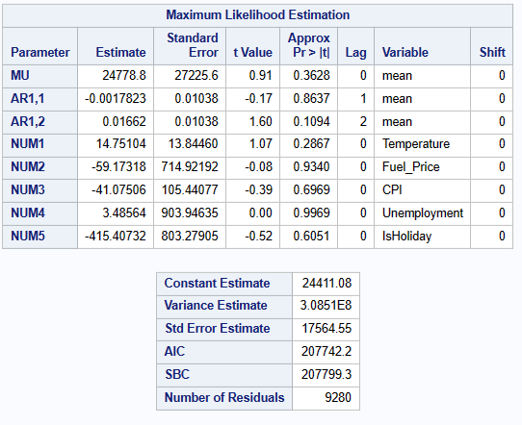

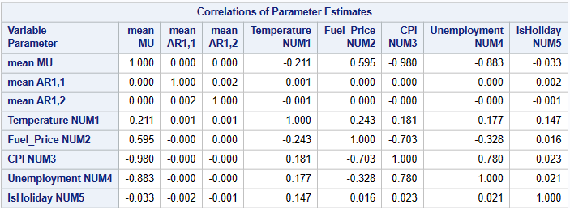

The parameter estimates indicate high values for the independent variables (>0.001) and hence indicate that the model is not good to generate sales forecasts.

1. **Model and forecast outputs:**

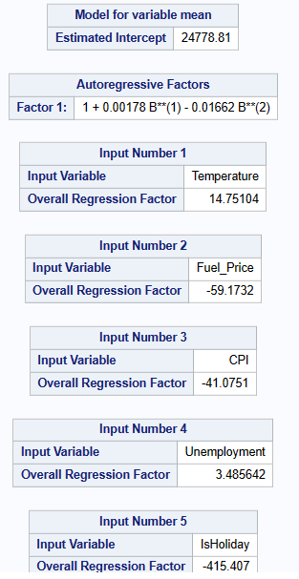

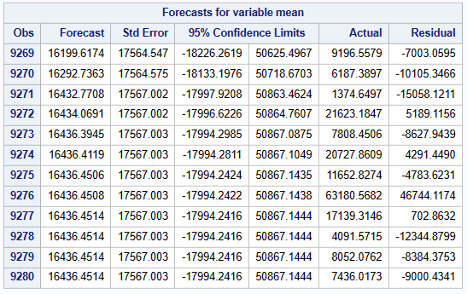

The forecast is shown for 12 months as that is the hold out period and residual is calculated only for that duration.

**Model 7: ARIMAX(0,2)**

The fourth model was created using ARIMAX and had below parameters:

p = 0

q = 2

With the same, below were the outputs:

1. **Correlation for mean**:

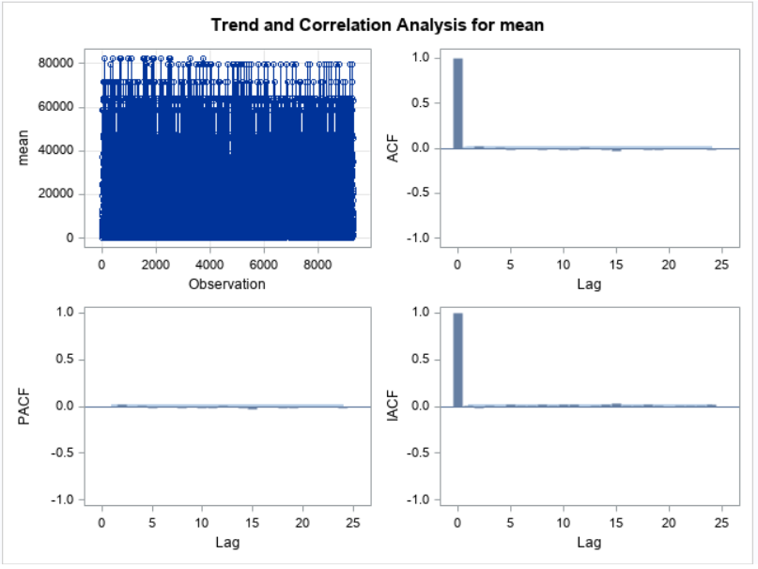

Through ACF graph, it is evident that there is no autocorrelation. Also, there are extremely small spikes in the PACF and the IACF graphs.

1. **Residual plots:**

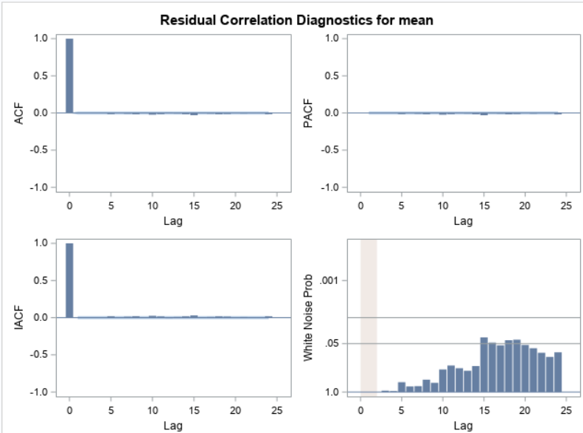

The results show that the white noise test fails for the residuals with some spikes above the threshold and hence, the model is not able to capture all the systematic variation existing in the dataset well. Also, there is no autocorrelation that exists in the residual plot and hence is great.

1. **Residual normality check:**

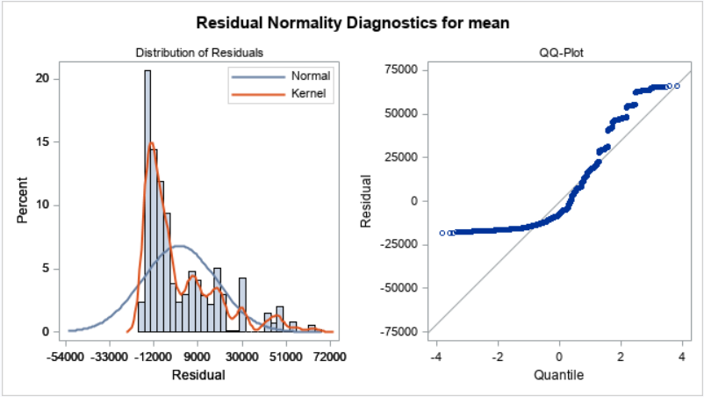

The above plot indicates that the residual graph again is not normal and shows right skewness and kurtosis.

1. **Autocorrelation check for residuals:**

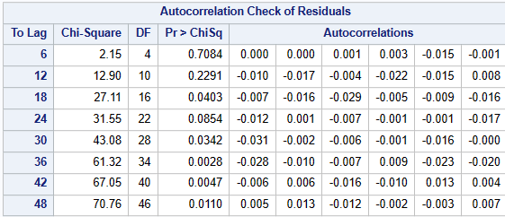

The above table indicates that there is barely any auto – correlation existing amongst the residuals and hence is great.

1. **Parameter estimates:**

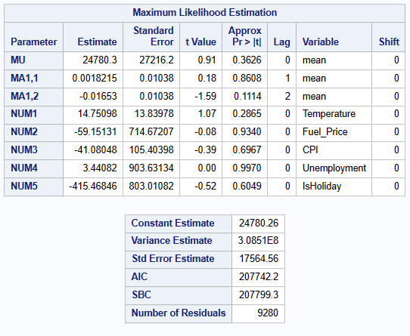

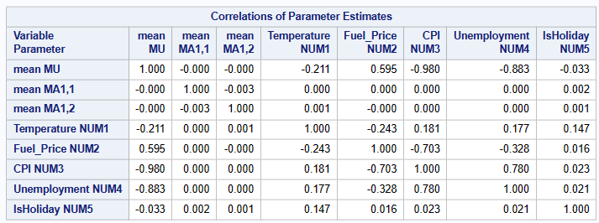

The parameter estimates indicate high values for the independent variables (>0.001) and hence indicate that the model is not good to generate sales forecasts.

1. **Model and forecast outputs:**

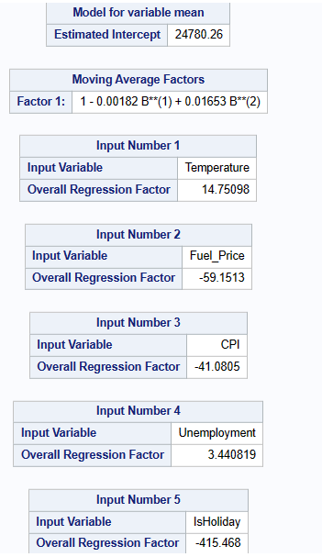

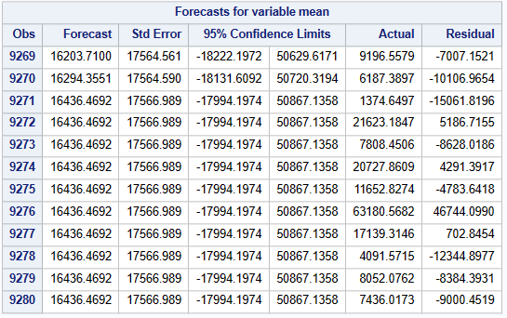

The forecast is shown for 12 months as that is the hold out period and residual is calculated only for that duration.

**Model 8: ARIMAX(2,2)**

The fourth model was created using ARIMAX and had below parameters:

p = 2

q = 2

With the same, below were the outputs:

1. **Correlation for mean**:

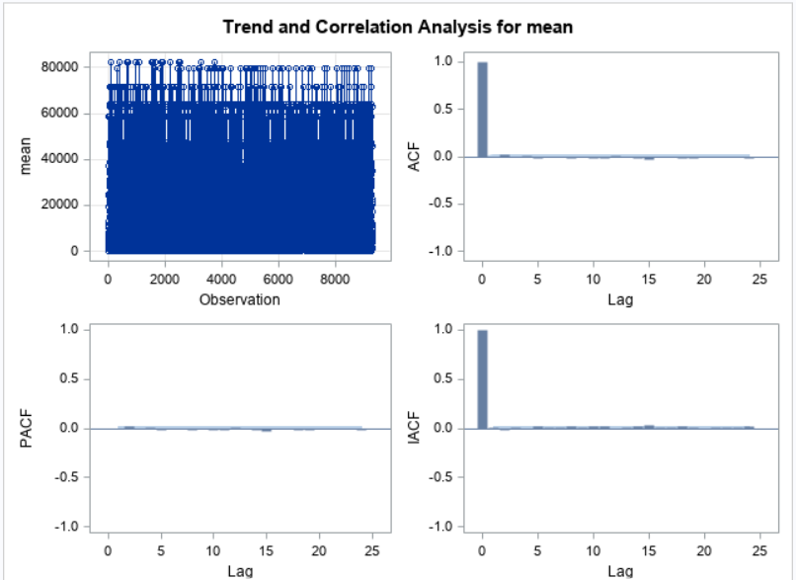

Through ACF graph, it is evident that there is no autocorrelation. Also, there are extremely small spikes in the PACF and the IACF graphs.

1. **Residual plots:**

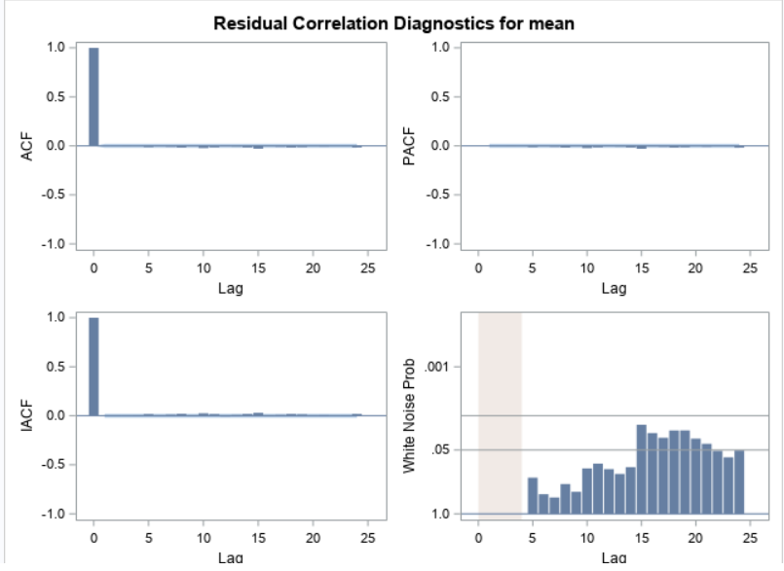

The results show that the white noise test fails for the residuals with some spikes above the threshold and hence, the model is not able to capture all the systematic variation existing in the dataset well. Also, there is no autocorrelation that exists in the residual plot and hence is great.

1. **Residual normality check:**

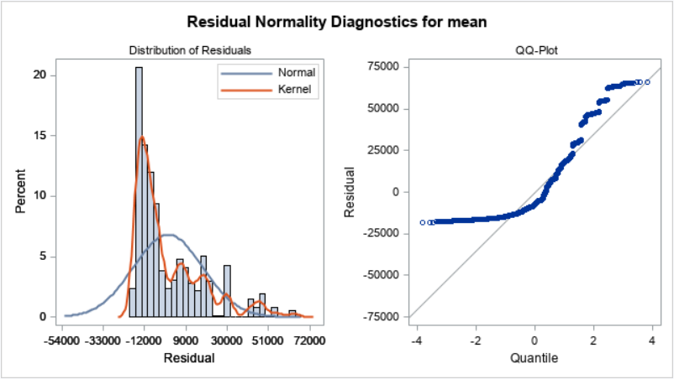

The above plot indicates that the residual graph again is not normal and shows right skewness and kurtosis.

1. **Autocorrelation check for residuals:**

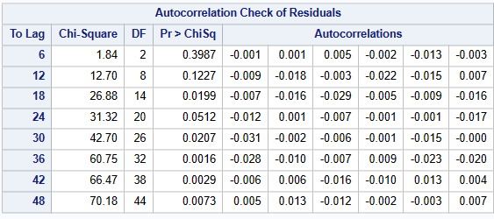

The above table indicates that there is barely any auto – correlation existing amongst the residuals and hence is great.

1. **Parameter estimates:**

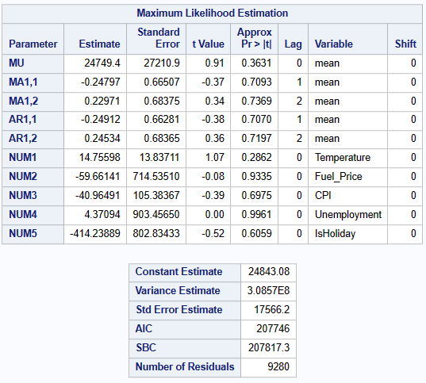

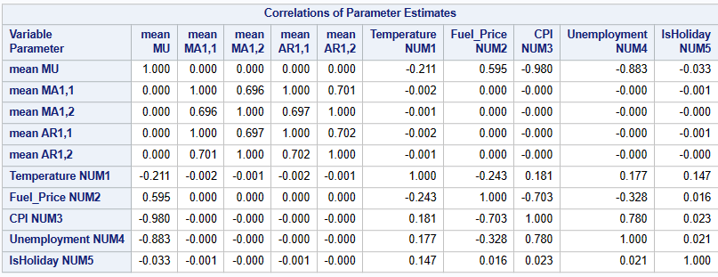

The parameter estimates indicate high values for the independent variables (>0.001) and hence indicate that the model is not good to generate sales forecasts.

1. **Model and forecast outputs:**

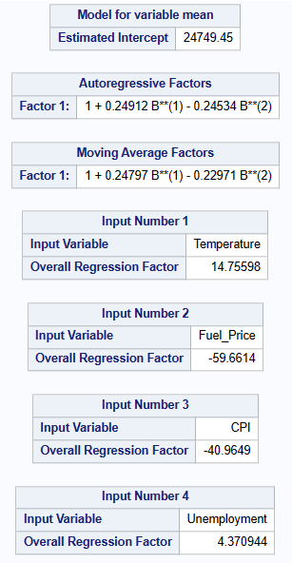

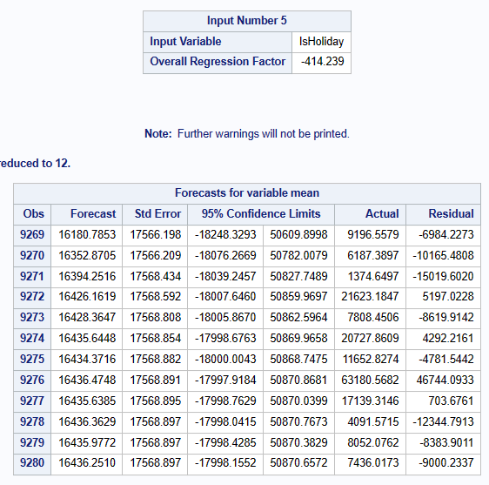

The forecast is shown for 12 months as that is the hold out period and residual is calculated only for that duration.

1. **Model comparison**

**5.1 Accuracy & fit statistics with and without hold out sample:**

Considering the models created above, the selection of best model was done based on the Accuracy and fit statistics. The measures for all the 8 models created using a **HOLDOUT** sample of 12 months as below:

|  |  |  |  |  |  |  |  |  |  |  |  |  |  |  |
| --- | --- | --- | --- | --- | --- | --- | --- | --- | --- | --- | --- | --- | --- | --- |
| **Models** | **SSE** | | **n** | | **p** | | **MSE** | | **MAPE** | | **AIC** | | **SBC** | |
| ARIMAX(2,0) | 3790941127794 | 9280 | | 8 | | 408859052 | | 2.22% | | 210334.4 | | 210391.5 | |
| ARIMAX(1,0) | 4244368791590 | 9280 | | 7 | | 457712584 | | 4.02% | | 211380.5 | | 211430.4 | |
| ARIMAX(2,2) | 2883675746369 | 9280 | | 10 | | 311076132 | | 4.14% | | 207808.5 | | 207879.8 | |
| ARIMAX(0,2) | 2861874675199 | 9280 | | 8 | | 308657752 | | 4.30% | | 207734.3 | | 207791.4 | |
| ARIMAX(0,0) | 2861335610903 | 9280 | | 6 | | 308533061 | | 4.58% | | 207740.8 | | 207783.6 | |
| ARIMAX(1,1) | 2862478387514 | 9280 | | 8 | | 308722863 | | 4.69% | | 207736.2 | | 207793.3 | |
| ARIMA(0,2) | 2862062283406 | 9280 | | 3 | | 308511618 | | 5.00% | | 207724.9 | | 207746.3 | |
| ARIMAX(0,1) | 2862621818212 | 9280 | | 7 | | 308705038 | | 5.23% | | 207734.7 | | 207784.7 | |

Here, the model with best accuracy was ARIMAX(2,0). For the same, the MAPE stands at 2.22% which far better in comparison to the rest of the models. Hence, fit statistics is not needed to select the best model based on parsimony.

For this best model, below is the accuracy and fit statistics **without the HOLDOUT sample**:

|  |  |  |  |  |  |  |  |  |  |  |  |  |  |  |
| --- | --- | --- | --- | --- | --- | --- | --- | --- | --- | --- | --- | --- | --- | --- |
| **Models** | **SSE** | | **n** | | **p** | | **MSE** | | **MAPE** | | **AIC** | | **SBC** | |
| ARIMAX(2,0) |  |  | |  | |  | |  | |  | |  | |

**5.2 Final Forecasting Parameters & Equation:**

|  |  |
| --- | --- |
| **Models** | **Model Equation:** |
| ARIMAX(2,0) | Y(t) + 0.00178Y(t-1) – 0.0162Y(t-2) = 24778.8 + 14.75T(t) – 59.1F(t) – 41.07C(t) + 3.4U(t) – 415H(t) |
| ARIMAX(1,0) | Y(t) + 0.0018139 Y(t-1) = 24775.6 + 14.78 T(t) – 59.84 F(t) – 41.05 C(t) + 3.48 U(t) – 417.65 H(t) |
| ARIMAX(2,2) | Y(t) + 0.2479 Y(t-1) – 0.2297 Y(t-2) = 24749 + 0.249 E(t-1) – 0.245 E(t-2) + 14.75 T(t) – 59.66 F(t) – 40.96 C(t) + 4.37 U(t) – 414.23 H(t) |
| ARIMAX(0,2) | Y(t) = 24780.3 - 0.0018215 E(t-1) +0.01653 E(t-2) + 14.7 T(t) - 59.15 F(t) - 41.08 C(t) + 3.44082 U(t) - 415.46 H(t) |
| ARIMAX(0,0) | Y(t) = 24775.7 + 14.7799 T(t) -59.84902 F(t) -41.0582 C(t)+3.47377 U(t)-417.73928 H(t) |
| ARIMAX(1,1) | Y(t) = 24769.5 -0.96893Y(t-1) + 0.96438 E(t-1) + 14.78 T(t) -59.472 F(t) -41.05 C(t) + 3.86 U(t) -414.13H(t) |
| ARIMA(0,2) | Y(t) = 16737.0 - 0.0015602 E(t-1) + 0.01682 E(t-2) |
| ARIMAX(0,1) | Y(t) = 24775.6 - 0.0017395 E(t-1) + 14.78097 T(t) - 59.84472 F(t) - 41.05870 C(t) + 3.48384 U(t) - 417.65779 H(t) |